## Describe Azure storage services.

### Compare Azure Storage services.

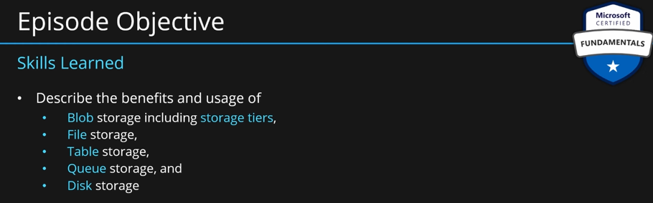

**Types of data:**

**Structured Data:** Data is well defined. Data can be described using a schema. For example, a data stored in a table. Each row of the table, we can defined what is the type of each value. Each row you add to the table must follow the schema. We can also define relationships between data present in different tables. These are **relational databases.**

**Semi-structured Data:** You have tables and rows. But each row of the table does not need to follow any specific schema. You row can have its own unique properties. Common property among the rows is usually a key like id.

**Unstructured Data:** Data like images, movies, applications, text files etc.

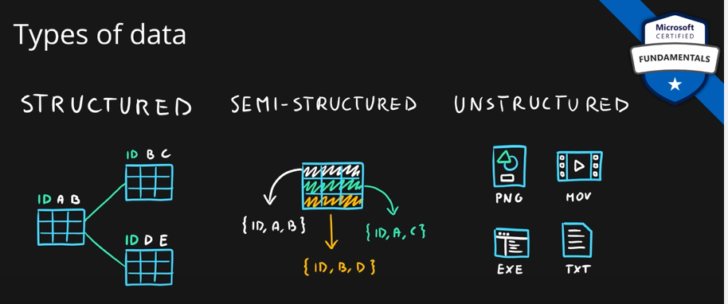

**Describe Azure storage accounts:**

A storage account provides a unique namespace for your Azure Storage data that's accessible from anywhere in the world over HTTP or HTTPS. Data in this account is secure, highly available, durable, and massively scalable.

When you create your storage account, you’ll start by picking the storage account type. The type of account determines the storage services and redundancy options and has an impact on the use cases. Below is a list of redundancy options that will be covered later in this module:

* Locally redundant storage (LRS)
* Geo-redundant storage (GRS)
* Read-access geo-redundant storage (RA-GRS)
* Zone-redundant storage (ZRS)
* Geo-zone-redundant storage (GZRS)
* Read-access geo-zone-redundant storage (RA-GZRS)

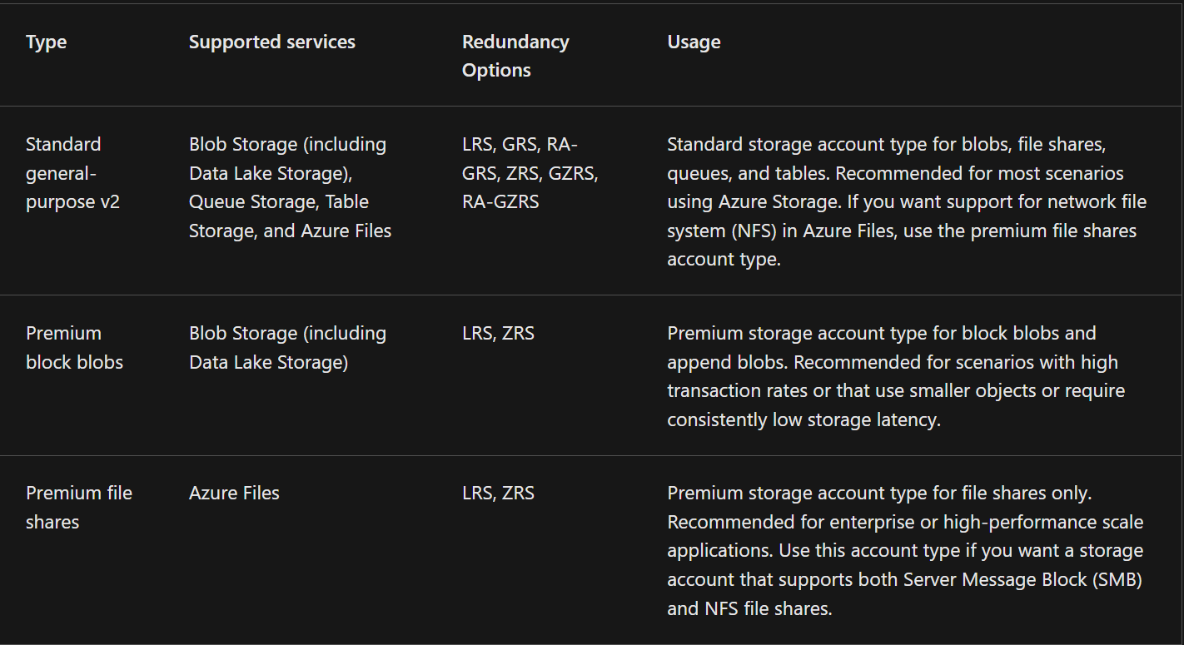

**Storage account endpoints:**

One of the benefits of using an Azure Storage Account is having a unique namespace in Azure for your data. In order to do this, every storage account in Azure must have a unique-in-Azure account name. **The combination of the account name and the Azure Storage service endpoint forms the endpoints for your storage account.**

When naming your storage account, keep these rules in mind:

* Storage account names must be between 3 and 24 characters in length and may contain numbers and lowercase letters only.
* Your storage account name must be unique within Azure. No two storage accounts can have the same name. This supports the ability to have a unique, accessible namespace in Azure.

**The following table shows the endpoint format for Azure Storage services.**

**Storage service Endpoint**

**Blob Storage https://<storage-account-name>.blob.core.windows.net**

**Data Lake Storage Gen2 https://<storage-account-name>.dfs.core.windows.net**

**Azure Files https://<storage-account-name>.file.core.windows.net**

**Queue Storage https://<storage-account-name>.queue.core.windows.net**

**Table Storage https://<storage-account-name>.table.core.windows.net**

**Azure Storage Account:** Blob storage, table storage, queue storage, file storage, are all part of a bigger service called **azure storage account.**

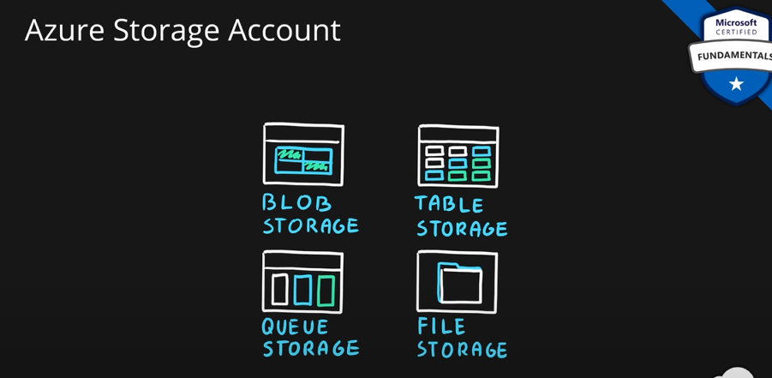

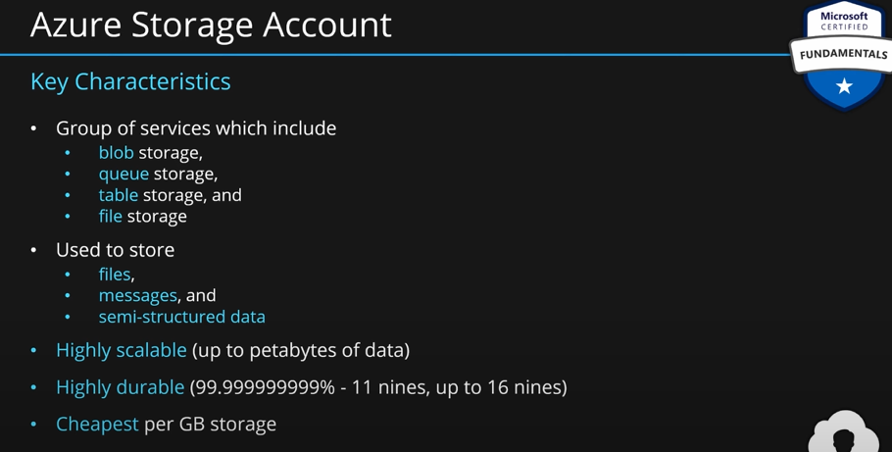

**Creating storage account:**

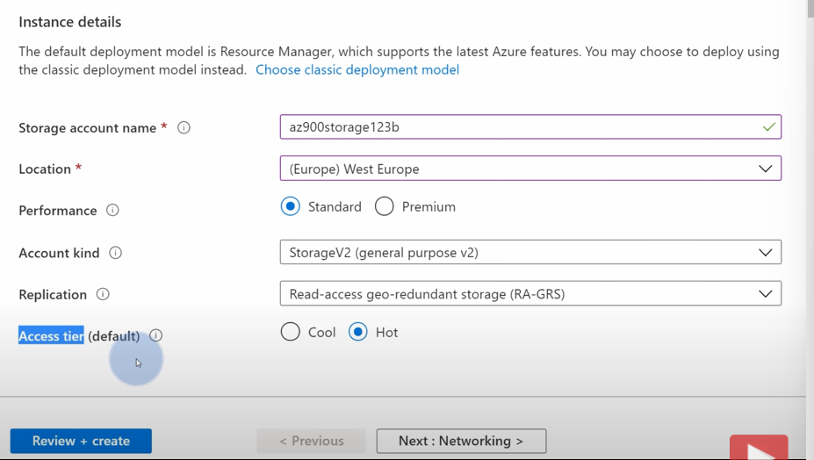

**Inside Storage Account:**

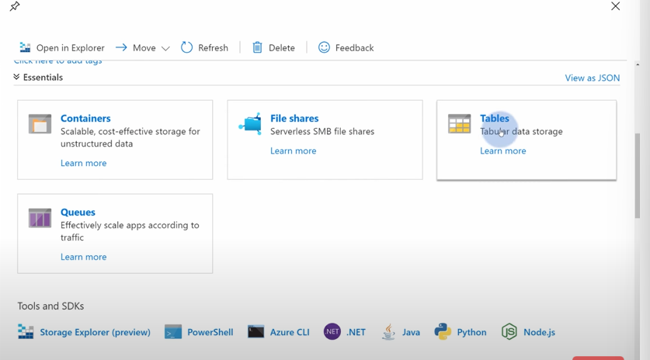

You can store blobs inside the **container**.

You can mount an azure storage as your local storage using file shares.

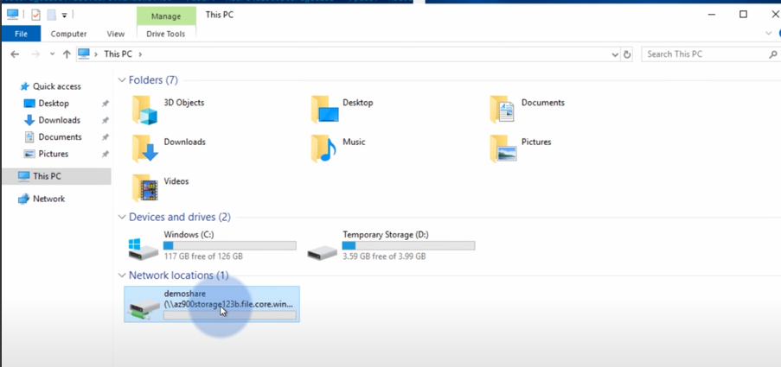

You can open this drive, create folder, files, or anything inside this drive.

### Describe redundancy options.

**Describe Azure storage redundancy:**

Azure Storage always stores multiple copies of your data so that it's protected from planned and unplanned events such as transient hardware failures, network or power outages, and natural disasters. Redundancy ensures that your storage account meets its availability and durability targets even in the face of failures.

When deciding which redundancy option is best for your scenario**, consider the tradeoffs between lower costs and higher availability**. The factors that help determine which redundancy option you should choose include:

* How your data is replicated in the primary region.
* Whether your data is replicated to a second region that is geographically distant to the primary region, to protect against regional disasters.
* Whether your application requires read access to the replicated data in the secondary region if the primary region becomes unavailable.

**Redundancy in the primary region:**

Data in an Azure Storage account is always replicated three times in the primary region. Azure Storage offers two options for how your data is replicated in the primary region, locally redundant storage (LRS) and zone-redundant storage (ZRS).

**Locally redundant storage:**

Locally redundant storage (LRS) replicates your data three times within a single data center in the primary region. LRS provides at least 11 nines of durability (99.999999999%) of objects over a given year.

Diagram showing the structure used for locally redundant storage.

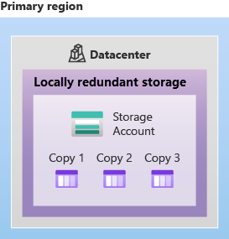

LRS is the lowest-cost redundancy option and offers the least durability compared to other options. LRS protects your data against server rack and drive failures. However, if a disaster such as fire or flooding occurs within the data center, all replicas of a storage account using LRS may be lost or unrecoverable. To mitigate this risk, Microsoft recommends using zone-redundant storage (ZRS), geo-redundant storage (GRS), or geo-zone-redundant storage (GZRS).

**Zone-redundant storage:**

For Availability Zone-enabled Regions, zone-redundant storage (ZRS) replicates your Azure Storage data synchronously across three Azure availability zones in the primary region. ZRS offers durability for Azure Storage data objects of at least 12 nines (99.9999999999%) over a given year.

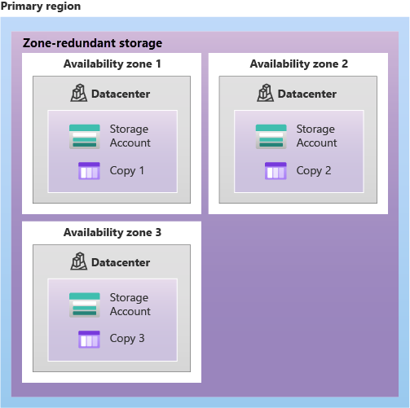

With ZRS, your data is still accessible for both read and write operations even if a zone becomes unavailable. No remounting of Azure file shares from the connected clients is required. If a zone becomes unavailable, Azure undertakes networking updates, such as DNS repointing. These updates may affect your application if you access data before the updates have completed.

Microsoft recommends using ZRS in the primary region for scenarios that require high availability. ZRS is also recommended for restricting replication of data within a country or region to meet data governance requirements.

**Redundancy in a secondary region:**

For applications requiring high durability, you can choose to additionally copy the data in your storage account to a secondary region that is hundreds of miles away from the primary region. If the data in your storage account is copied to a secondary region, then your data is durable even in the event of a catastrophic failure that prevents the data in the primary region from being recovered.

When you create a storage account, you select the primary region for the account. The paired secondary region is based on Azure Region Pairs and can't be changed.

Azure Storage offers two options for copying your data to a secondary region: **geo-redundant storage (GRS)** and **geo-zone-redundant storage (GZRS)**. GRS is similar to running LRS in two regions, and GZRS is similar to running ZRS in the primary region and LRS in the secondary region.

By default, data in the secondary region isn't available for read or write access unless there's a failover to the secondary region. If the primary region becomes unavailable, you can choose to fail over to the secondary region. After the failover has completed, the secondary region becomes the primary region, and you can again read and write data.

Because data is replicated to the secondary region asynchronously, a failure that affects the primary region may result in data loss if the primary region can't be recovered. The interval between the most recent writes to the primary region and the last write to the secondary region is known as the recovery point objective (RPO). The RPO indicates the point in time to which data can be recovered. Azure Storage typically has an RPO of less than 15 minutes, although there's currently no SLA on how long it takes to replicate data to the secondary region.

**Geo-redundant storage:**

GRS copies your data synchronously three times within a single physical location in the primary region using LRS. It then copies your data asynchronously to a single physical location in the secondary region (the region pair) using LRS. GRS offers durability for Azure Storage data objects of at least 16 nines (99.99999999999999%) over a given year.

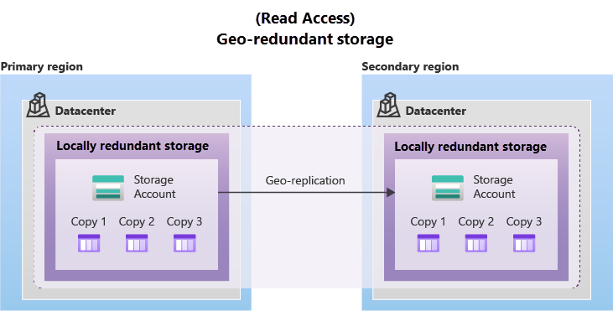

**Geo-zone-redundant storage:**

GZRS combines the high availability provided by redundancy across availability zones with protection from regional outages provided by geo-replication. Data in a GZRS storage account is copied across three Azure availability zones in the primary region (similar to ZRS) and is also replicated to a secondary geographic region, using LRS, for protection from regional disasters. Microsoft recommends using GZRS for applications requiring maximum consistency, durability, and availability, excellent performance, and resilience for disaster recovery.

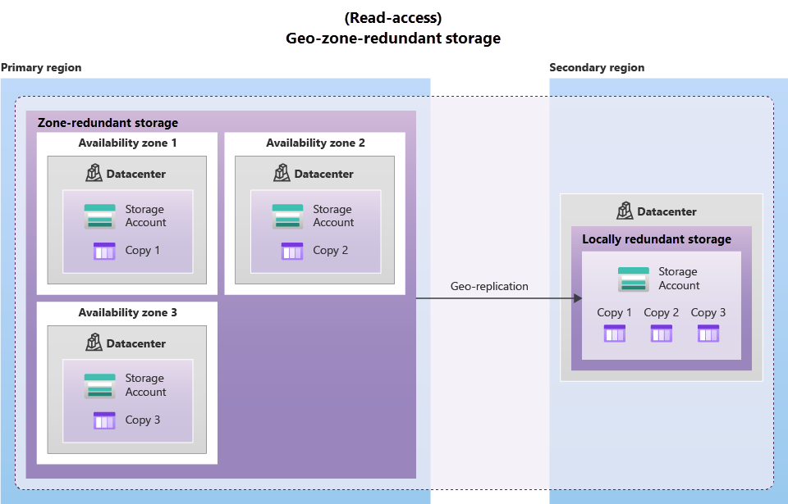

GZRS is designed to provide at least 16 nines (99.99999999999999%) of durability of objects over a given year.

**Read access to data in the secondary region:**

Geo-redundant storage (with GRS or GZRS) replicates your data to another physical location in the secondary region to protect against regional outages. However, that data is available to be read only if the customer or Microsoft initiates a failover from the primary to secondary region. However, if you enable read access to the secondary region, your data is always available, even when the primary region is running optimally. For read access to the secondary region, enable read-access geo-redundant storage (RA-GRS) or read-access geo-zone-redundant storage (RA-GZRS).

Remember that the data in your secondary region may not be up-to-date due to RPO.

**Describe Azure storage services:**

The Azure Storage platform includes the following data services:

**Azure Blobs:** A massively scalable object store for text and binary data. Also includes support for big data analytics through Data Lake Storage Gen2.

**Azure Files:** Managed file shares for cloud or on-premises deployments.

**Azure Queues:** A messaging store for reliable messaging between application components.

**Azure Disks:** Block-level storage volumes for Azure VMs.

**Azure Tables:** NoSQL table option for structured, non-relational data.

Benefits of Azure Storage

Azure Storage services offer the following benefits for application developers and IT professionals:

**Durable and highly available.** Redundancy ensures that your data is safe if transient hardware failures occur. You can also opt to replicate data across data centers or geographical regions for additional protection from local catastrophes or natural disasters. Data replicated in this way remains highly available if an unexpected outage occurs.

**Secure**. All data written to an Azure storage account is encrypted by the service. Azure Storage provides you with fine-grained control over who has access to your data.

**Scalable**. Azure Storage is designed to be massively scalable to meet the data storage and performance needs of today's applications.

**Managed**. Azure handles hardware maintenance, updates, and critical issues for you.

**Accessible**. Data in Azure Storage is accessible from anywhere in the world over HTTP or HTTPS. Microsoft provides client libraries for Azure Storage in a variety of languages, including .NET, Java, Node.js, Python, PHP, Ruby, Go, and others, as well as a mature REST API. Azure Storage supports scripting in Azure PowerShell or Azure CLI. And the Azure portal and Azure Storage Explorer offer easy visual solutions for working with your data.

**Azure Blob Storage:** Any kind of **unstructured data** can be called a **blob**. **BLOB means Binary Large Object.** So, any kind of a file is called a blob. We can put these **blobs** in **azure blob storage** inside a **container**. **Container** is a **bucket** for multiple blobs. We can have any number of containers inside azure blob storage. Both applications and users can access these containers.

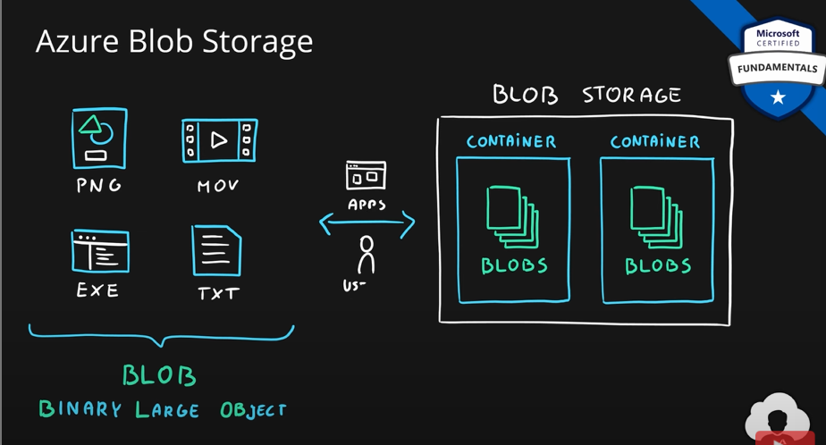

Azure Blob storage is an object storage solution for the cloud. It can store massive amounts of data, such as text or binary data. Azure Blob storage is unstructured, meaning that there are no restrictions on the kinds of data it can hold. Blob storage can manage thousands of simultaneous uploads, massive amounts of video data, constantly growing log files, and can be reached from anywhere with an internet connection.

Blobs aren't limited to common file formats. A blob could contain gigabytes of binary data streamed from a scientific instrument, an encrypted message for another application, or data in a custom format for an app you’re developing. One advantage of blob storage over disk storage is that it doesn't require developers to think about or manage disks. Data is uploaded as blobs, and Azure takes care of the physical storage needs.

Blob storage is ideal for:

**Serving images or documents directly to a browser.**

**Storing files for distributed access.**

**Streaming video and audio.**

**Storing data for backup and restore, disaster recovery, and archiving.**

**Storing data for analysis by an on-premises or Azure-hosted service.**

**Accessing blob storage:**

Objects in blob storage can be accessed from anywhere in the world via HTTP or HTTPS. Users or client applications can access blobs via URLs, the Azure Storage REST API, Azure PowerShell, Azure CLI, or an Azure Storage client library. The storage client libraries are available for multiple languages, including .NET, Java, Node.js, Python, PHP, and Ruby.

### Describe storage tiers.

Azure provides three types of storage tiers for better performance and better pricing depending on how often you access your data.

Data stored in the cloud can grow at an exponential pace. To manage costs for your expanding storage needs, it's helpful to organize your data based on attributes like frequency of access and planned retention period. Data stored in the cloud can be handled differently based on how it's generated, processed, and accessed over its lifetime. Some data is actively accessed and modified throughout its lifetime. Some data is accessed frequently early in its lifetime, with access dropping drastically as the data ages. Some data remains idle in the cloud and is rarely, if ever, accessed after it's stored. To accommodate these different access needs, Azure provides several access tiers, which you can use to balance your storage costs with your access needs.

Azure Storage offers different access tiers for your blob storage, helping you store object data in the most cost-effective manner. The available access tiers include:

**Hot: Optimized for storing data that is accessed frequently (for example, images for your website).** Use this **for frequently access data**. For example, if you have a web app which serves images to the customer, you can put those images in hot tier. They provide **best performance**.

**Cool: Optimized for data that is infrequently accessed and stored for at least 30 days (for example, invoices for your customers). less frequently accessed data.** **Lower availability and lower performance. Provides high durability**. You also get a significant discount on storing your data. You can store **order versions, backups etc**. in this tier.

**Cold access tier**: Optimized for storing data that is infrequently accessed and stored for at least 90 days.

**Archive: Appropriate for data that is rarely accessed and stored for at least 180 days, with flexible latency requirements (for example, long-term backups).** If you have **very rarely accessed data,** then you can store that in **archive**. Let’s say you have a **very long-term backup** you need to keep for ten years. **Availability is very low,** retrieving this data might even take few hours. But the **price is also the lowest**. Archive gives you the lowest price per GB in azure.

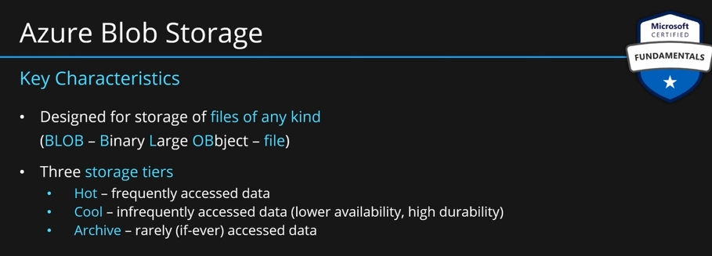

**The following considerations apply to the different access tiers:**

Hot and cool access tiers can be set at the account level. The cold and archive access tiers aren't available at the account level.

Hot, cool, cold, and archive tiers can be set at the blob level, during or after upload.

Data in the cool and cold access tiers can tolerate slightly lower availability, but still requires high durability, retrieval latency, and throughput characteristics similar to hot data. For cool and cold data, a lower availability service-level agreement (SLA) and higher access costs compared to hot data are acceptable trade-offs for lower storage costs.

Archive storage stores data offline and offers the lowest storage costs, but also the highest costs to rehydrate and access data.

**Azure Queue Storage (AQS):** If you have an application which has several tasks to complete. Each of these tasks might take some time to complete. You can output these to azure queue as separate messages. This will allow background services to pick up these messages and process them asynchronously. This is offload your frontend application. It will also help you to pick up more suitable services for background processing.

Azure Queue storage is a service for storing large numbers of messages. Once stored, you can access the messages from anywhere in the world via authenticated calls using HTTP or HTTPS. A queue can contain as many messages as your storage account has room for (potentially millions). Each individual message can be up to 64 KB in size. Queues are commonly used to create a backlog of work to process asynchronously.

Queue storage can be combined with compute functions like Azure Functions to take an action when a message is received. For example, you want to perform an action after a customer uploads a form to your website. You could have the submit button on the website trigger a message to the Queue storage. Then, you could use Azure Functions to trigger an action once the message was received.

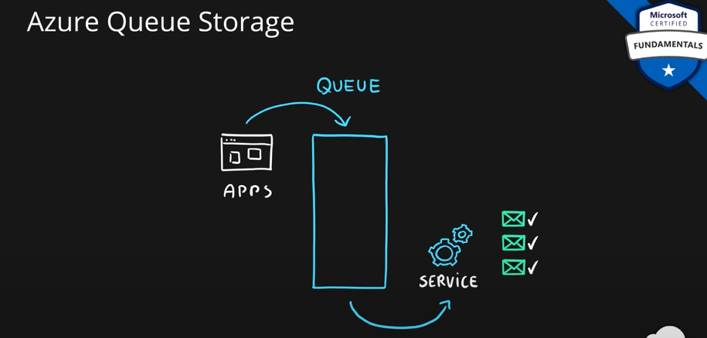

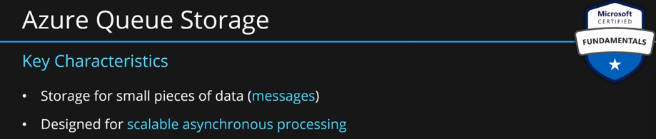

**Azure Disks:**

Azure Disk storage, or Azure managed disks, are block-level storage volumes managed by Azure for use with Azure VMs. Conceptually, they’re the same as a physical disk, but they’re virtualized – offering greater resiliency and availability than a physical disk. With managed disks, all you have to do is provision the disk, and Azure will take care of the rest.

Used for VMs. In VMs, we have multiple partitions. All of these partitions are stored on one or more disks. This is provided my azure disk storage service. It is emulation of disk in the cloud. They provide storage for both OS and application data on VM.

Disk can be **managed** or **unmanaged**. Unmanaged means each disk is stored as a file on blob storage. It is not managed by cloud provider, hence unmanaged. Customers are responsible for managing the files on blob storage. Managed disks mean MS will manage the blob storage and file and everything. User don’t manage anything.

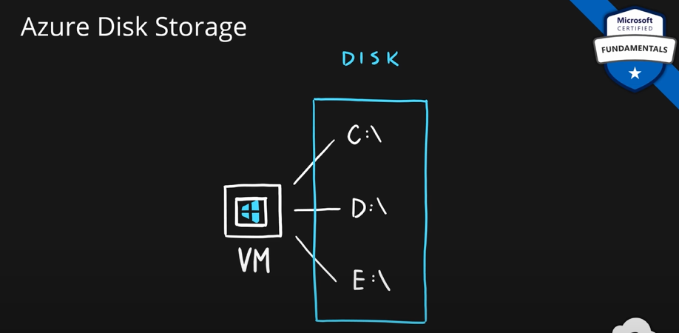

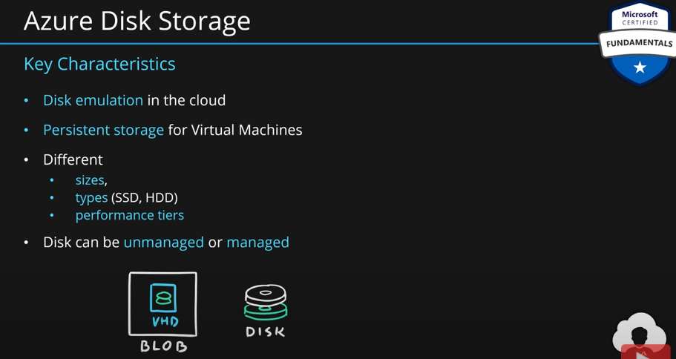

**Azure Table Storage:** Designed for **semi-structured data**. Application or user can submit semi-structured data forms into tables. You can have any number of tables. It is just like a DB where you store tables. It is semi-structured database. There are no joins or schemas. Also called No-SQL database. Use it when you don’t need foreign keys, schemas, relationships. It is designed for fast access. Even if you have petabytes of data, you can still get result within milli seconds, if you use a compound key.

Azure Table storage stores large amounts of structured data. Azure tables are a NoSQL datastore that accepts authenticated calls from inside and outside the Azure cloud. This enables you to use Azure tables to build your hybrid or multi-cloud solution and have your data always available. Azure tables are ideal for storing structured, non-relational data.

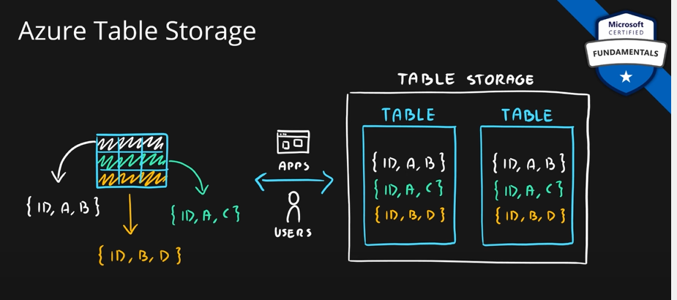

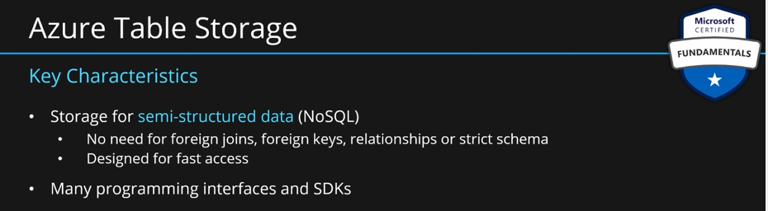

**Azure File Storage:**

Azure File storage offers fully managed file shares in the cloud that are accessible via the industry standard Server Message Block (SMB) or Network File System (NFS) protocols. Azure Files file shares can be mounted concurrently by cloud or on-premises deployments. SMB Azure file shares are accessible from Windows, Linux, and macOS clients. NFS Azure Files shares are accessible from Linux or macOS clients. Additionally, SMB Azure file shares can be cached on Windows Servers with Azure File Sync for fast access near where the data is being used.

**Azure Files key benefits:**

**Shared access:** Azure file shares support the industry standard SMB and NFS protocols, meaning you can seamlessly replace your on-premises file shares with Azure file shares without worrying about application compatibility.

**Fully managed**: Azure file shares can be created without the need to manage hardware or an OS. This means you don't have to deal with patching the server OS with critical security upgrades or replacing faulty hard disks.

**Scripting and tooling:** PowerShell cmdlets and Azure CLI can be used to create, mount, and manage Azure file shares as part of the administration of Azure applications. You can create and manage Azure file shares using Azure portal and Azure Storage Explorer.

**Resiliency**: Azure Files has been built from the ground up to always be available. Replacing on-premises file shares with Azure Files means you don't have to wake up in the middle of the night to deal with local power outages or network issues.

**Familiar programmability:** Applications running in Azure can access data in the share via file system I/O APIs. Developers can therefore use their existing code and skills to migrate existing applications. In addition to System IO APIs, you can use Azure Storage Client Libraries or the Azure Storage REST API.

Very simple to **azure blob storage**. Some **semantic** difference is there:

**Blobs 🡪 files, container 🡪 share, blob storage 🡪 file storage.**

There are same in every way. The difference is the way you access them.

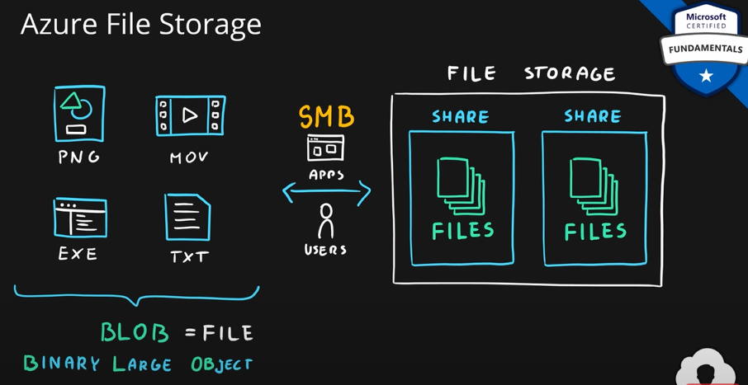

In case of file storage, you access your files using **SMB protocol.**

**Network drives in windows are azure file storage.**

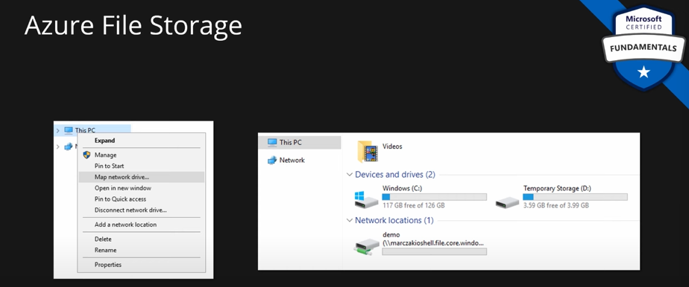

They are designed for two scenarios: if your company already has file shares and want to extend them for more space then you can use this service. Or a common use case is lift and shift. You already have an existing application. You don’t want to redesign your application to make use of azure blob storage. You still want to extend your space or move files to azure. In that case, you can use file storage, mount it as a local drive, point your application to the local drive and use native functionality. This share is in azure. So, your files are now stored in azure without any need to redesign your existing application.

Basically you use file storage if you need that **shared drive protocol.** Otherwise you redesign your application and make use of the blob storage.

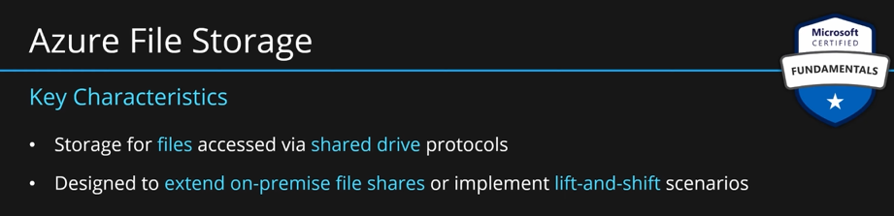

**Summary:**

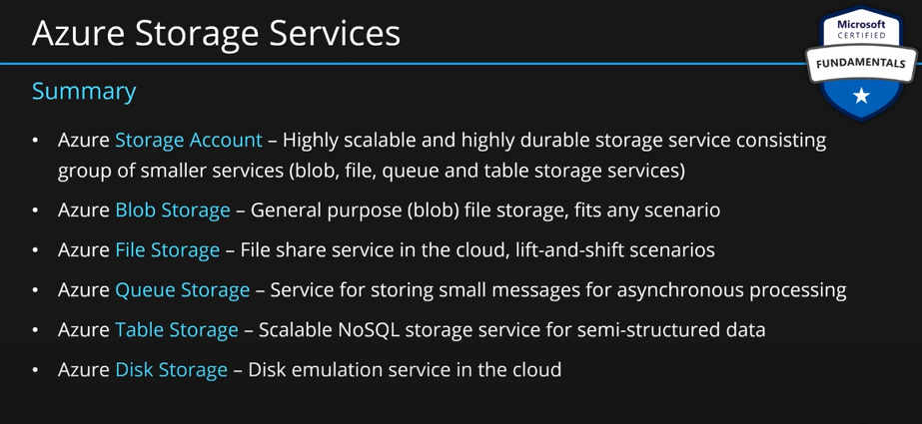

### Describe migration options, including Azure Migrate and Azure Data Box.

**Identify Azure data migration options:**

Now that you understand the different storage options within Azure, it’s important to also understand how to get your data and information into Azure. Azure supports both real-time migration of infrastructure, applications, and data using Azure Migrate as well as asynchronous migration of data using Azure Data Box.

**Azure Migrate**

Azure Migrate is a service that helps you migrate from an on-premises environment to the cloud. Azure Migrate functions as a hub to help you manage the assessment and migration of your on-premises datacenter to Azure. It provides the following:

* **Unified migration platform**: A single portal to start, run, and track your migration to Azure.
* **Range of tools:** A range of tools for assessment and migration. Azure Migrate tools include Azure Migrate: Discovery and assessment and Azure Migrate: Server Migration. Azure Migrate also integrates with other Azure services and tools, and with independent software vendor (ISV) offerings.
* **Assessment and migration:** In the Azure Migrate hub, you can assess and migrate your on-premises infrastructure to Azure.

**Integrated tools**

In addition to working with tools from ISVs, the Azure Migrate hub also includes the following tools to help with migration:

* **Azure Migrate:** Discovery and assessment. Discover and assess on-premises servers running on VMware, Hyper-V, and physical servers in preparation for migration to Azure.
* **Azure Migrate: Server Migration**. Migrate VMware VMs, Hyper-V VMs, physical servers, other virtualized servers, and public cloud VMs to Azure.
* **Data Migration Assistant**. Data Migration Assistant is a stand-alone tool to assess SQL Servers. It helps pinpoint potential problems blocking migration. It identifies unsupported features, new features that can benefit you after migration, and the right path for database migration.
* **Azure Database Migration Service**. Migrate on-premises databases to Azure VMs running SQL Server, Azure SQL Database, or SQL Managed Instances.
* **Azure App Service migration assistant**. Azure App Service migration assistant is a standalone tool to assess on-premises websites for migration to Azure App Service. Use Migration Assistant to migrate .NET and PHP web apps to Azure.
* **Azure Data Box**. Use Azure Data Box products to move large amounts of offline data to Azure.

**Azure Data Box**

Azure Data Box is a physical migration service that helps transfer large amounts of data in a quick, inexpensive, and reliable way. The secure data transfer is accelerated by shipping you a proprietary Data Box storage device that has a maximum usable storage capacity of 80 terabytes. The Data Box is transported to and from your datacenter via a regional carrier. A rugged case protects and secures the Data Box from damage during transit.

You can order the Data Box device via the Azure portal to import or export data from Azure. Once the device is received, you can quickly set it up using the local web UI and connect it to your network. Once you’re finished transferring the data (either into or out of Azure), simply return the Data Box. If you’re transferring data into Azure, the data is automatically uploaded once Microsoft receives the Data Box back. The entire process is tracked end-to-end by the Data Box service in the Azure portal.

**Use cases:**

Data Box is ideally suited to transfer data sizes larger than 40 TBs in scenarios with no to limited network connectivity. The data movement can be one-time, periodic, or an initial bulk data transfer followed by periodic transfers.

Here are the various scenarios where Data Box can be used to import data to Azure.

* **Onetime migration** - when a large amount of on-premises data is moved to Azure.
* **Moving a media library** from offline tapes into Azure to create an online media library.
* **Migrating your VM farm, SQL server, and applications to Azure.**
* **Moving historical data** to Azure for in-depth analysis and reporting using HDInsight.
* **Initial bulk transfer -** when an initial bulk transfer is done using Data Box (seed) followed by incremental transfers over the network.
* **Periodic uploads** - when large amount of data is generated periodically and needs to be moved to Azure.

Here are the various scenarios where Data Box can be used to export data from Azure.

* **Disaster recovery** - when a copy of the data from Azure is restored to an on-premises network. In a typical disaster recovery scenario, a large amount of Azure data is exported to a Data Box. Microsoft then ships this Data Box, and the data is restored on your premises in a short time.
* **Security requirements** - when you need to be able to export data out of Azure due to government or security requirements.
* **Migrate back to on-premises or to another cloud service provider -** when you want to move all the data back to on-premises, or to another cloud service provider, export data via Data Box to migrate the workloads.

Once the data from your import order is uploaded to Azure, the disks on the device are wiped clean in accordance with NIST 800-88r1 standards. For an export order, the disks are erased once the device reaches the Azure datacenter.

### Identify options for moving files, including AzCopy, Azure Storage Explorer, and Azure File Sync.

**Identify Azure file movement options:**

In addition to large scale migration using services like Azure Migrate and Azure Data Box, Azure also has tools designed to help you move or interact with individual files or small file groups. Among those tools are AzCopy, Azure Storage Explorer, and Azure File Sync.

**AzCopy**

**AzCopy** is a command-line utility that you can use to copy blobs or files to or from your storage account. With AzCopy, you can upload files, download files, copy files between storage accounts, and even synchronize files. AzCopy can even be configured to work with other cloud providers to help move files back and forth between clouds.

Synchronizing blobs or files with AzCopy is one-direction synchronization. When you synchronize, you designated the source and destination, and AzCopy will copy files or blobs in that direction. It doesn't synchronize bi-directionally based on timestamps or other metadata.

**Azure Storage Explorer**

Azure Storage Explorer is a standalone app that provides a graphical interface to manage files and blobs in your Azure Storage Account. It works on Windows, macOS, and Linux operating systems and uses AzCopy on the backend to perform all of the file and blob management tasks. With Storage Explorer, you can upload to Azure, download from Azure, or move between storage accounts.

**Azure File Sync**

Azure File Sync is a tool that lets you centralize your file shares in Azure Files and keep the flexibility, performance, and compatibility of a Windows file server. It’s almost like turning your Windows file server into a miniature content delivery network. Once you install Azure File Sync on your local Windows server, it will automatically stay bi-directionally synced with your files in Azure.

With Azure File Sync, you can:

* Use any protocol that's available on Windows Server to access your data locally, including SMB, NFS, and FTPS.
* Have as many caches as you need across the world.
* Replace a failed local server by installing Azure File Sync on a new server in the same datacenter.
* Configure cloud tiering so the most frequently accessed files are replicated locally, while infrequently accessed files are kept in the cloud until requested.

### Describe Azure identity, access, and security.

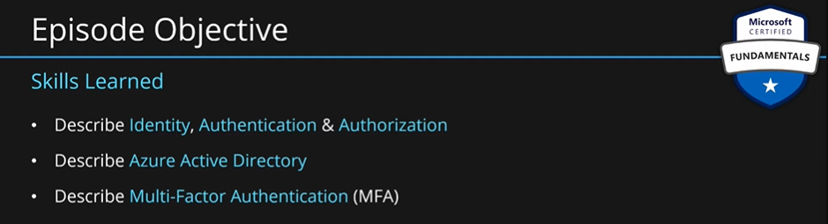

**Identity:** Being someone is called identity. A user with **username and password** is an identity. Identity can also mean an application or a server which will identify itself with a secret key or certificate. When we login to azure portal, we use our identity.

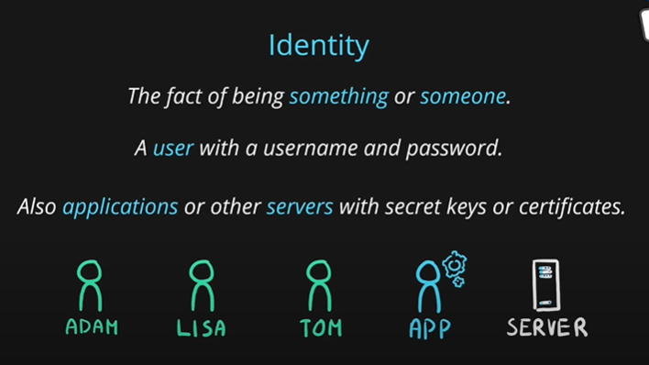

The process of verifying identity is called **authentication**.

**Authentication** is the process of establishing the identity of a person, service, or device. It requires the person, service, or device to provide some type of credential to prove who they are. Authentication is like presenting ID when you’re traveling. It doesn’t confirm that you’re ticketed, it just proves that you’re who you say you are. Azure supports multiple authentication methods, including standard passwords, single sign-on (SSO), multifactor authentication (MFA), and passwordless.

For the longest time, security and convenience seemed to be at odds with each other. Thankfully, new authentication solutions provide both security and convenience.

The following diagram shows the security level compared to the convenience. Notice Passwordless authentication is high security and high convenience while passwords on their own are low security but high convenience.

A user will present itself to the auth server saying it is x. Auth server will ask x for some secret to verify he is actually x. x provides the password to auth server. Auth server has now verified that x is called x. This is authentication.

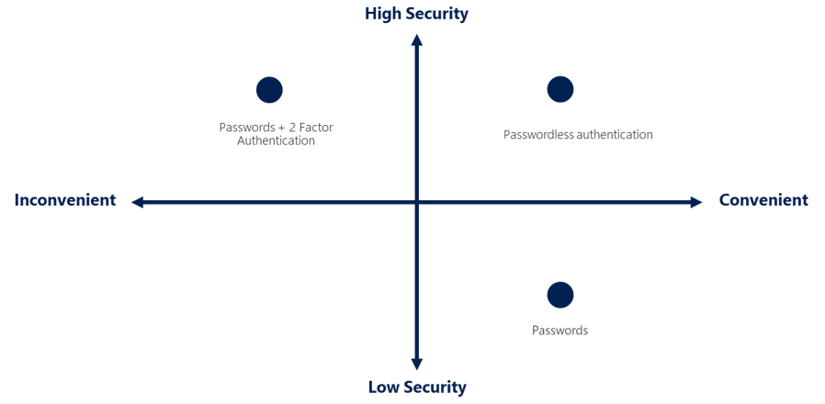

This exact process happens when we log in to the azure portal.

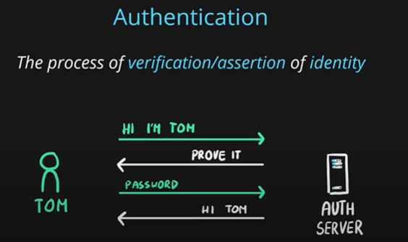

Now, after login, x might try to perform some action. Let’s say x wants to create a new VM. Now, we need to verify weather x has the access to create a VM. This process is called **authorization**. The access will be granted by the resource owner.

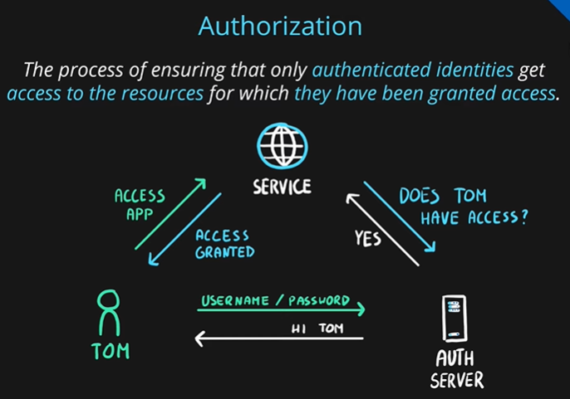

Services can authorization on their own or can contact a external service to get this information.

If you can see a resource group in azure, that means you already have the access to view it.

All actions withing azure, creating a resource, deleting it and many more, all require authorization.

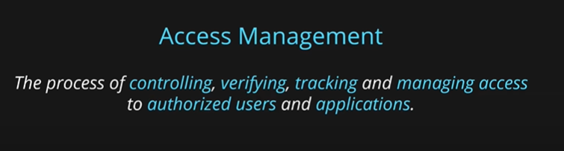

All actions we do in azure such as managing subscription, VM related, DB related, resources related, all of these actions go through **Azure AD.**

**Azure AD is now known as Microsoft Entra ID**

**Azure AD** is managing all the identities ie user accounts. It grants permissions to access azure resources and it governs access to those specific resources.

Microsoft Entra ID is a directory service that enables you to sign in and access both Microsoft cloud applications and cloud applications that you develop. Microsoft Entra ID can also help you maintain your on-premises Active Directory deployment.

Azure AD does not only work with azure portal but also with live.com services such as skype, OneDrive, outlook etc. Your live.com account is also stored in azure AD. Also, Azure AD will manage your organizational resources as well which are also OneDrive, outlook etc.

For on-premises environments, Active Directory running on Windows Server provides an identity and access management service that's managed by your organization. Microsoft Entra ID is Microsoft's cloud-based identity and access management service. With Microsoft Entra ID, you control the identity accounts, but Microsoft ensures that the service is available globally. If you've worked with Active Directory, Microsoft Entra ID will be familiar to you.

When your secure identities on-premises with Active Directory, Microsoft doesn't monitor sign-in attempts. When you connect Active Directory with Microsoft Entra ID, Microsoft can help protect you by detecting suspicious sign-in attempts at no extra cost. For example, Microsoft Entra ID can detect sign-in attempts from unexpected locations or unknown devices.

Azure AD manages your users, groups, licenses, and access to services.

You can also use azure AD features such as authentication and authorization in your own application.

Who uses Microsoft Entra ID?

**Microsoft** **Entra** **ID** **is** **for**:

* **IT administrators.** Administrators can use Microsoft Entra ID to control access to applications and resources based on their business requirements.
* **App developers.** Developers can use Microsoft Entra ID to provide a standards-based approach for adding functionality to applications that they build, such as adding SSO functionality to an app or enabling an app to work with a user's existing credentials.
* **Users**. Users can manage their identities and take maintenance actions like self-service password reset.
* **Online service subscribers**. Microsoft 365, Microsoft Office 365, Azure, and Microsoft Dynamics CRM Online subscribers are already using Microsoft Entra ID to authenticate into their account.

**What does Microsoft Entra ID do?**

**Microsoft Entra ID provides services such as:**

* **Authentication**: This includes verifying identity to access applications and resources. It also includes providing functionality such as self-service password reset, multifactor authentication, a custom list of banned passwords, and smart lockout services.
* **Single sign-on:** Single sign-on (SSO) enables you to remember only one username and one password to access multiple applications. A single identity is tied to a user, which simplifies the security model. As users change roles or leave an organization, access modifications are tied to that identity, which greatly reduces the effort needed to change or disable accounts.
* **Application** **management**: You can manage your cloud and on-premises apps by using Microsoft Entra ID. Features like Application Proxy, SaaS apps, the My Apps portal, and single sign-on provide a better user experience.
* **Device** **management**: Along with accounts for individual people, Microsoft Entra ID supports the registration of devices. Registration enables devices to be managed through tools like Microsoft Intune. It also allows for device-based Conditional Access policies to restrict access attempts to only those coming from known devices, regardless of the requesting user account.

**Can I connect my on-premises AD with Microsoft Entra ID?**

If you had an on-premises environment running Active Directory and a cloud deployment using Microsoft Entra ID, you would need to maintain two identity sets. However, you can connect Active Directory with Microsoft Entra ID, enabling a consistent identity experience between cloud and on-premises.

One method of connecting Microsoft Entra ID with your on-premises AD is using **Microsoft Entra Connect**. Microsoft Entra Connect synchronizes user identities between on-premises Active Directory and Microsoft Entra ID. Microsoft Entra Connect synchronizes changes between both identity systems, so you can use features like SSO, multifactor authentication, and self-service password reset under both systems.

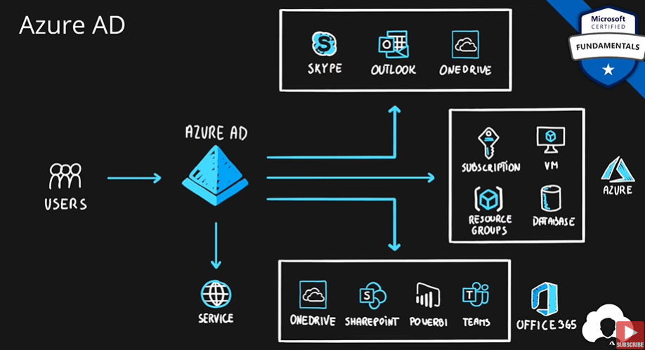

Note: You can only manage all aspects azure AD, if you have global administrator role.

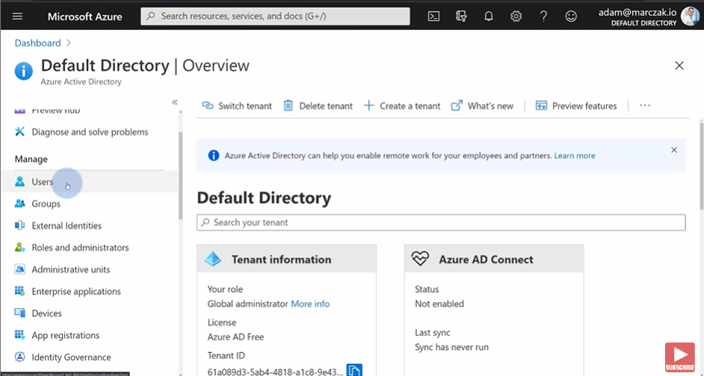

From the left menus, you can manage users, groups etc.

If your organization uses their own on premises active directory, you can use a sync service to **sync** these accounts to azure AD. This is particularly helpful for hybrid cloud environments.

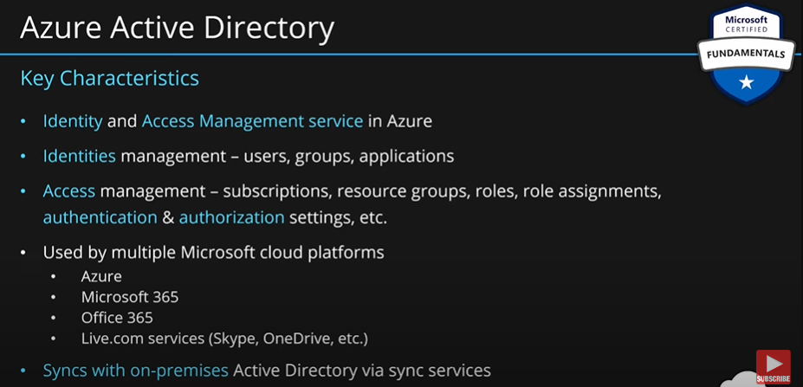

**What is Microsoft Entra Domain Services?**

Microsoft Entra Domain Services is a service that provides managed domain services such as domain join, group policy, lightweight directory access protocol (LDAP), and Kerberos/NTLM authentication. Just like Microsoft Entra ID lets you use directory services without having to maintain the infrastructure supporting it, with Microsoft Entra Domain Services, you get the benefit of domain services without the need to deploy, manage, and patch domain controllers (DCs) in the cloud.

A Microsoft Entra Domain Services managed domain lets you run legacy applications in the cloud that can't use modern authentication methods, or where you don't want directory lookups to always go back to an on-premises AD DS environment. You can lift and shift those legacy applications from your on-premises environment into a managed domain, without needing to manage the AD DS environment in the cloud.

Microsoft Entra Domain Services integrates with your existing Microsoft Entra tenant. This integration lets users sign into services and applications connected to the managed domain using their existing credentials. You can also use existing groups and user accounts to secure access to resources. These features provide a smoother lift-and-shift of on-premises resources to Azure.

How does Microsoft Entra Domain Services work?

When you create a Microsoft Entra Domain Services managed domain, you define a unique namespace. This namespace is the domain name. Two Windows Server domain controllers are then deployed into your selected Azure region. This deployment of DCs is known as a replica set.

You don't need to manage, configure, or update these DCs. The Azure platform handles the DCs as part of the managed domain, including backups and encryption at rest using Azure Disk Encryption.

**Is information synchronized?**

A managed domain is configured to perform a one-way synchronization from Microsoft Entra ID to Microsoft Entra Domain Services. You can create resources directly in the managed domain, but they aren't synchronized back to Microsoft Entra ID. In a hybrid environment with an on-premises AD DS environment, Microsoft Entra Connect synchronizes identity information with Microsoft Entra ID, which is then synchronized to the managed domain.

Applications, services, and VMs in Azure that connect to the managed domain can then use common Microsoft Entra Domain Services features such as domain join, group policy, LDAP, and Kerberos/NTLM authentication.

### Describe authentication methods in Azure, including single sign-on (SSO), multi-factor authentication (MFA), and passwordless.

**Authentication Methods:**

**What's single sign-on?**

**Single sign-on (SSO)** enables a user to sign in one time and use that credential to access multiple resources and applications from different providers. For SSO to work, the different applications and providers must trust the initial authenticator.

More identities mean more passwords to remember and change. Password policies can vary among applications. As complexity requirements increase, it becomes increasingly difficult for users to remember them. The more passwords a user has to manage, the greater the risk of a credential-related security incident.

Consider the process of managing all those identities. More strain is placed on help desks as they deal with account lockouts and password reset requests. If a user leaves an organization, tracking down all those identities and ensuring they're disabled can be challenging. If an identity is overlooked, this might allow access when it should have been eliminated.

With SSO, you need to remember only one ID and one password. Access across applications is granted to a single identity that's tied to the user, which simplifies the security model. As users change roles or leave an organization, access is tied to a single identity. This change greatly reduces the effort needed to change or disable accounts. Using SSO for accounts makes it easier for users to manage their identities and for IT to manage users.

Single sign-on is only as secure as the initial authenticator because the subsequent connections are all based on the security of the initial authenticator.

**Multi-factor Authentication:**

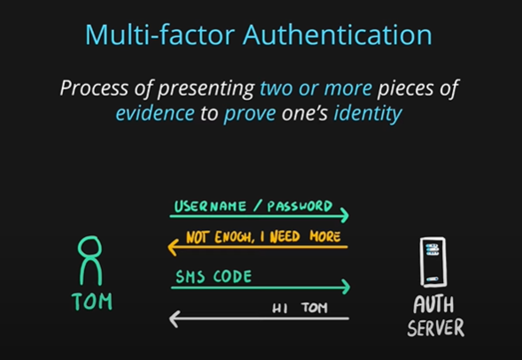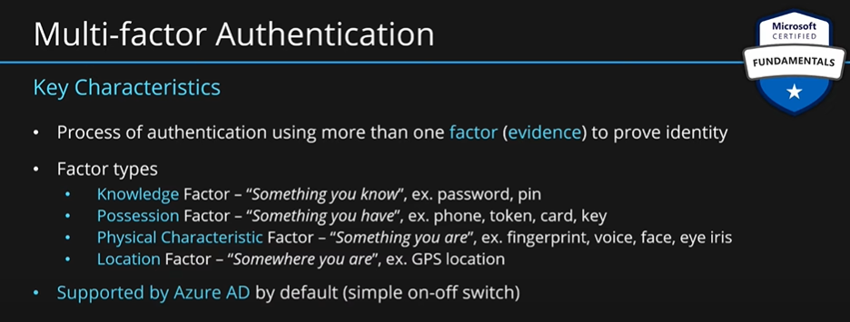

Multifactor authentication is the process of prompting a user for an extra form (or factor) of identification during the sign-in process. MFA helps protect against a password compromise in situations where the password was compromised but the second factor wasn't.

Think about how you sign into websites, email, or online services. After entering your username and password, have you ever needed to enter a code that was sent to your phone? If so, you've used multifactor authentication to sign in.

Multifactor authentication provides additional security for your identities by requiring two or more elements to fully authenticate. These elements fall into three categories:

**Something the user knows – this might be a challenge question.**

**Something the user has – this might be a code that's sent to the user's mobile phone.**

**Something the user is – this is typically some sort of biometric property, such as a fingerprint or face scan.**

Multifactor authentication increases identity security by limiting the impact of credential exposure (for example, stolen usernames and passwords). With multifactor authentication enabled, an attacker who has a user's password would also need to have possession of their phone or their fingerprint to fully authenticate.

Compare multifactor authentication with single-factor authentication. Under single-factor authentication, an attacker would need only a username and password to authenticate. Multifactor authentication should be enabled wherever possible because it adds enormous benefits to security.

**What's Microsoft Entra multifactor authentication?**

Microsoft Entra multifactor authentication is a Microsoft service that provides multifactor authentication capabilities. Microsoft Entra multifactor authentication enables users to choose an additional form of authentication during sign-in, such as a phone call or mobile app notification.

**What’s passwordless authentication?**

Features like MFA are a great way to secure your organization, but users often get frustrated with the additional security layer on top of having to remember their passwords. People are more likely to comply when it's easy and convenient to do so. Passwordless authentication methods are more convenient because the password is removed and replaced with something you have, plus something you are, or something you know.

Passwordless authentication needs to be set up on a device before it can work. For example, your computer is something you have. Once it’s been registered or enrolled, Azure now knows that it’s associated with you. Now that the computer is known, once you provide something you know or are (such as a PIN or fingerprint), you can be authenticated without using a password.

Each organization has different needs when it comes to authentication. Microsoft global Azure and Azure Government offer the following three passwordless authentication options that integrate with Microsoft Entra ID:

* **Windows Hello for Business**
* **Microsoft Authenticator app**
* **FIDO2 security keys**

**Windows Hello for Business**

Windows Hello for Business is ideal for information workers that have their own designated Windows PC. The biometric and PIN credentials are directly tied to the user's PC, which prevents access from anyone other than the owner. With public key infrastructure (PKI) integration and built-in support for single sign-on (SSO), Windows Hello for Business provides a convenient method for seamlessly accessing corporate resources on-premises and in the cloud.

**Microsoft Authenticator App**

You can also allow your employee's phone to become a passwordless authentication method. You may already be using the Microsoft Authenticator App as a convenient multifactor authentication option in addition to a password. You can also use the Authenticator App as a passwordless option.

The Authenticator App turns any iOS or Android phone into a strong, passwordless credential. Users can sign-in to any platform or browser by getting a notification to their phone, matching a number displayed on the screen to the one on their phone, and then using their biometric (touch or face) or PIN to confirm. Refer to Download and install the Microsoft Authenticator app for installation details.

**FIDO2 security keys**

The FIDO (Fast IDentity Online) Alliance helps to promote open authentication standards and reduce the use of passwords as a form of authentication. FIDO2 is the latest standard that incorporates the web authentication (WebAuthn) standard.

FIDO2 security keys are an unphishable standards-based passwordless authentication method that can come in any form factor. Fast Identity Online (FIDO) is an open standard for passwordless authentication. FIDO allows users and organizations to leverage the standard to sign-in to their resources without a username or password by using an external security key or a platform key built into a device.

Users can register and then select a FIDO2 security key at the sign-in interface as their main means of authentication. These FIDO2 security keys are typically USB devices but could also use Bluetooth or NFC. With a hardware device that handles the authentication, the security of an account is increased as there's no password that could be exposed or guessed.

### Describe external identities in Azure, including business-to-business (B2B) and business-to-customer (B2C)

**Describe Azure external identities**:

An external identity is a person, device, service, etc. that is outside your organization. Microsoft Entra External ID refers to all the ways you can securely interact with users outside of your organization. If you want to collaborate with partners, distributors, suppliers, or vendors, you can share your resources and define how your internal users can access external organizations. If you’re a developer creating consumer-facing apps, you can manage your customers' identity experiences.

External identities may sound similar to single sign-on. With External Identities, external users can "bring their own identities." Whether they have a corporate or government-issued digital identity, or an unmanaged social identity like Google or Facebook, they can use their own credentials to sign in. The external user’s identity provider manages their identity, and you manage access to your apps with Microsoft Entra ID or Azure AD B2C to keep your resources protected.

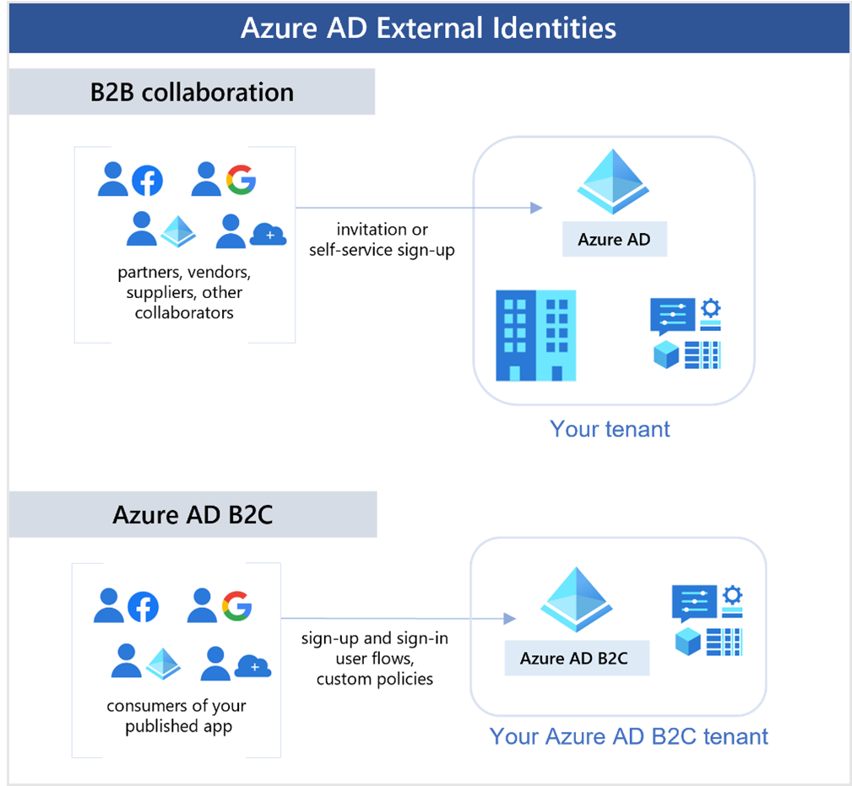

The following capabilities make up External Identities:

**Business to business (B2B) collaboration** - Collaborate with external users by letting them use their preferred identity to sign-in to your Microsoft applications or other enterprise applications (SaaS apps, custom-developed apps, etc.). B2B collaboration users are represented in your directory, typically as guest users.

**B2B direct connect** - Establish a mutual, two-way trust with another Microsoft Entra organization for seamless collaboration. B2B direct connect currently supports Teams shared channels, enabling external users to access your resources from within their home instances of Teams. B2B direct connect users aren't represented in your directory, but they're visible from within the Teams shared channel and can be monitored in Teams admin center reports.

**Microsoft Azure Active Directory business to customer (B2C)** - Publish modern SaaS apps or custom-developed apps (excluding Microsoft apps) to consumers and customers, while using Azure AD B2C for identity and access management.

Depending on how you want to interact with external organizations and the types of resources you need to share, you can use a combination of these capabilities.

With Microsoft Entra ID, you can easily enable collaboration across organizational boundaries by using the Microsoft Entra B2B feature. Guest users from other tenants can be invited by administrators or by other users. This capability also applies to social identities such as Microsoft accounts.

You also can easily ensure that guest users have appropriate access. You can ask the guests themselves or a decision maker to participate in an access review and recertify (or attest) to the guests' access. The reviewers can give their input on each user's need for continued access, based on suggestions from Microsoft Entra ID. When an access review is finished, you can then make changes and remove access for guests who no longer need it.

### Describe Microsoft Entra Conditional Access.

**Describe Azure conditional access:**

Conditional Access is a tool that Microsoft Entra ID uses to allow (or deny) access to resources based on identity signals. These signals include who the user is, where the user is, and what device the user is requesting access from.

Conditional Access helps IT administrators:

* Empower users to be productive wherever and whenever.
* Protect the organization's assets.

Conditional Access also provides a more granular multifactor authentication experience for users. For example, a user might not be challenged for second authentication factor if they're at a known location. However, they might be challenged for a second authentication factor if their sign-in signals are unusual or they're at an unexpected location.

During sign-in, Conditional Access collects signals from the user, makes decisions based on those signals, and then enforces that decision by allowing or denying the access request or challenging for a multifactor authentication response.

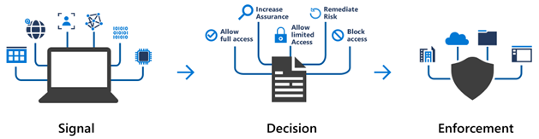

Here, the signal might be the user's location, the user's device, or the application that the user is trying to access.

Based on these signals, the decision might be to allow full access if the user is signing in from their usual location. If the user is signing in from an unusual location or a location that's marked as high risk, then access might be blocked entirely or possibly granted after the user provides a second form of authentication.

Enforcement is the action that carries out the decision. For example, the action is to allow access or require the user to provide a second form of authentication.

**When can I use Conditional Access?**

Conditional Access is useful when you need to:

* Require multifactor authentication (MFA) to access an application depending on the requestee’s role, location, or network. For example, you could require MFA for administrators but not regular users or for people connecting from outside your corporate network.
* Require access to services only through approved client applications. For example, you could limit which email applications are able to connect to your email service.
* Require users to access your application only from managed devices. A managed device is a device that meets your standards for security and compliance.
* Block access from untrusted sources, such as access from unknown or unexpected locations.

### Describe Azure role-based access control (RBAC).

**Role Based Access Control (RBAC):** Azure AD is a centralized service for identity and access management. The access management for azure resources is done through RBAC feature.

**Roles:** There are many services in azure. You can perform many actions on these services. For example, on VM, you can perform start VM, stop VM, attach disk and many more. Similarly, many actions can be performed on many resources.

If you want to allow certain users to perform certain actions on certain services, you can make use of the roles. You can create a role by bundling a number of actions on different services. For example, role has, for VM, create, stop and attach disk actions permission and for disk, update disk permission. You can create as many roles as you want.

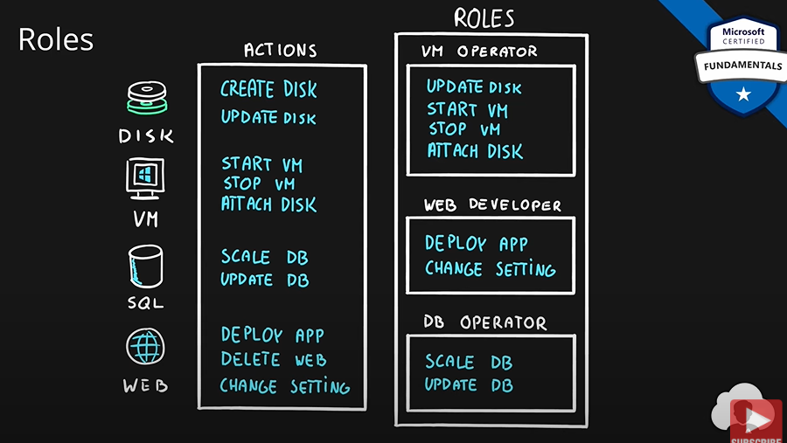

Azure provides many built-in roles which cover common scenarios.

Roles are assigned to identities such as users. A user’s role will tell which action this user can perform on the given azure service.

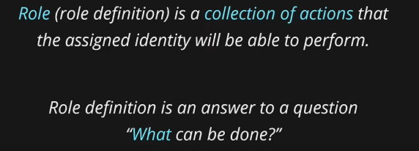

Role needs to be assigned to an identity. Identities are **security principles**. Security principles are objects withing azure which represent users or applications. Roles can be assigned to users, a group of users, service principles, application accounts in azure or application accounts that are tied to a specific service called managed identity. All the above are security principles.

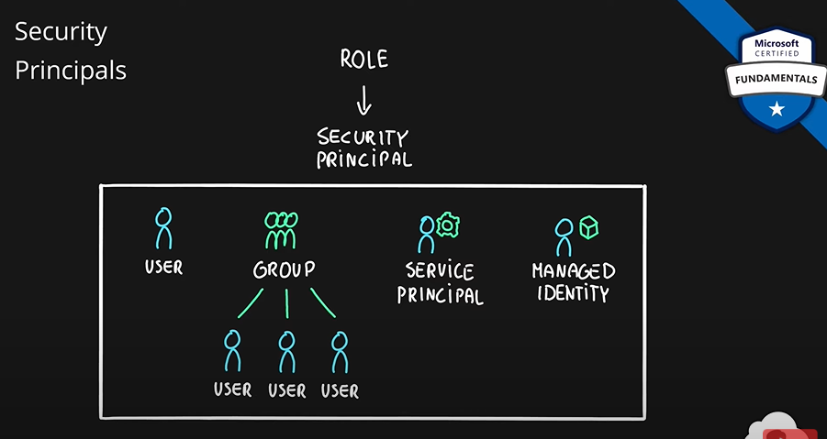

Let’s say we have a user Adam, we assign VM operator and DB operator roles to Adam. We can assign any number of roles to a user. This will help us in providing fine grained permissions to users to perform certain tasks.

We have another user, Tom. Tom is a web developer. Let’s assign the role of web developer to Tom. So, Tom can now perform necessary actions as per his need as a web developer.

If we assign a role to a group, all the people in that group will get the permissions.

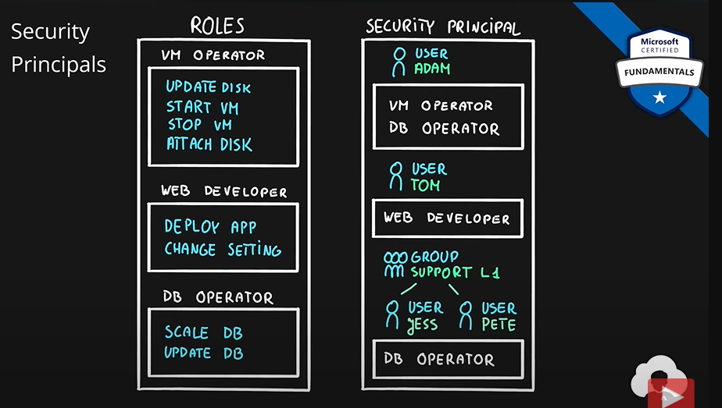

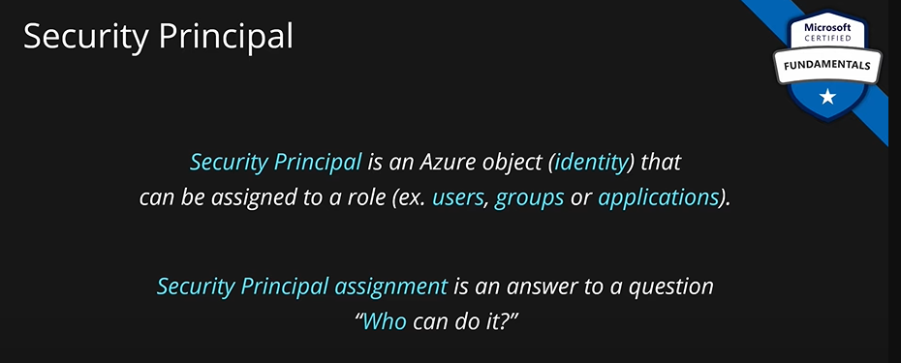 **Role: What can be done?**

**Security Principle: Who can do it?**

Roles need to be assigned a scope. Scope tells where these actions can be performed.

Azure has hierarchical structure. At the top of this hierarchy is **management group.** Under this we have **multiple subscriptions and management groups.** Subscription is top level billing object. Most people will have subscription as top-level resource in azure. Each subscription will have many **resource groups.** Each resource group will have many resources.

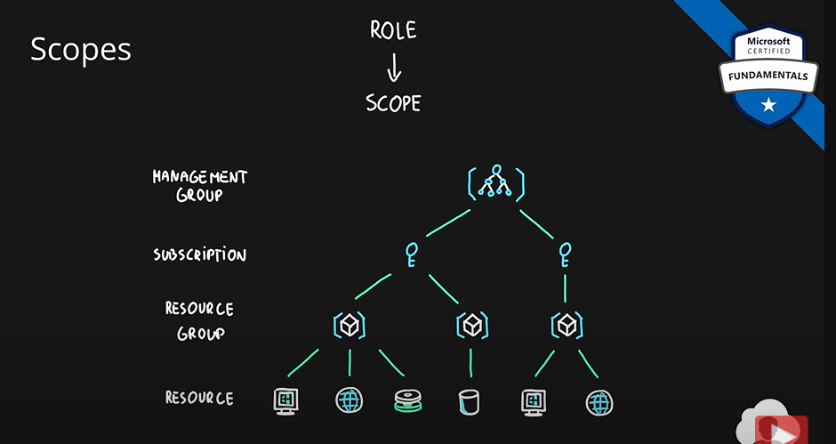

When you assign a role, you can assign it at any level. You can assign it at the top level, at the management group level. If so, the role will be inherited by all the child resources. So, the said security principle will be able to do those actions on any subscription, on any resource group and on any resource.

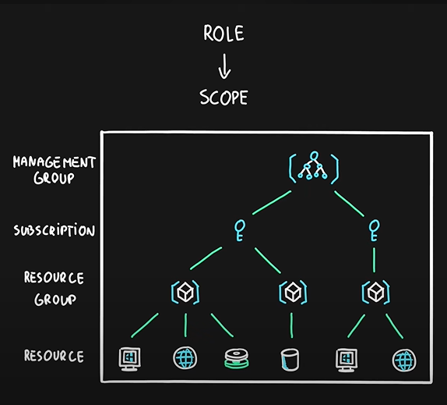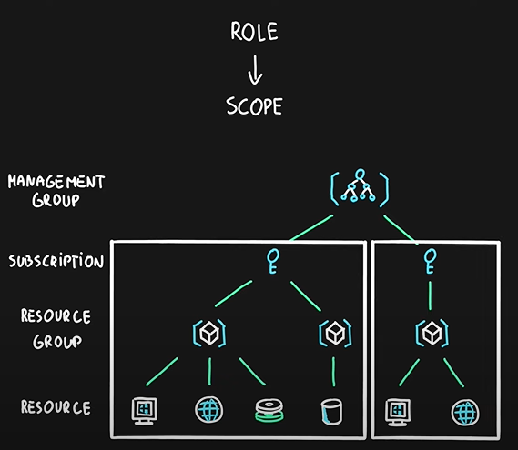

You can assign a role at a subscription level. The security principle whom this role is assigned to will only be able to do those actions within this subscription only.

You can also assign roles at resource groups or resource levels.

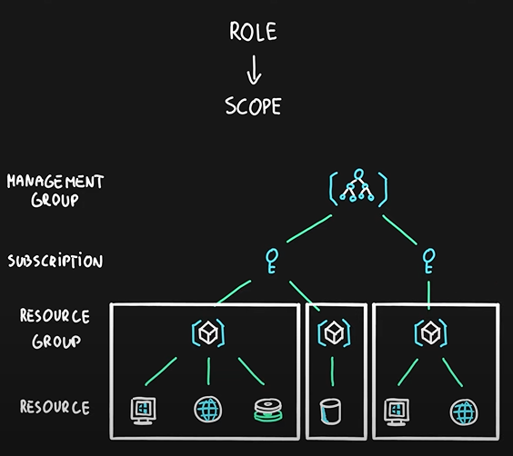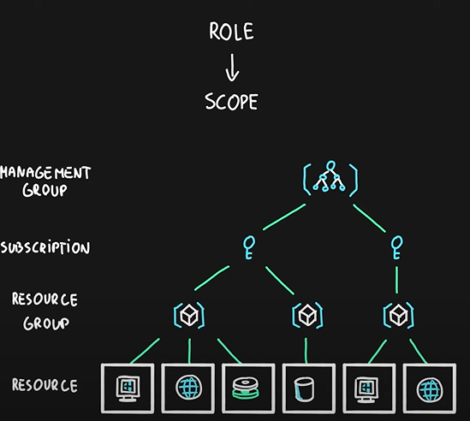

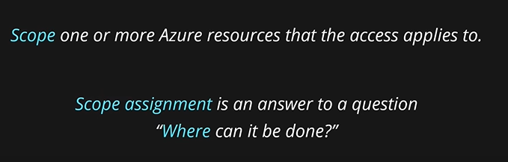

**Role: What can be done?**

**Security Principle: Who can do it?**

**Scope: Where it can be done?**

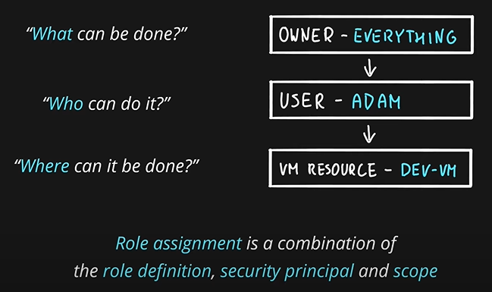

How is role-based access control applied to resources?

Role-based access control is applied to a scope, which is a resource or set of resources that this access applies to.

The following diagram shows the relationship between roles and scopes. A management group, subscription, or resource group might be given the role of owner, so they have increased control and authority. An observer, who isn't expected to make any updates, might be given a role of Reader for the same scope, enabling them to review or observe the management group, subscription, or resource group.

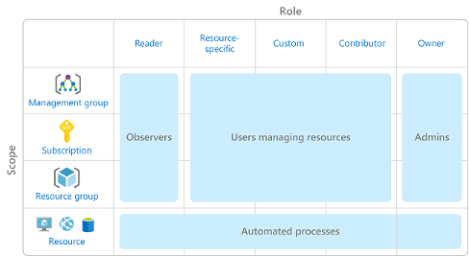

Scopes include:

* A management group (a collection of multiple subscriptions).
* A single subscription.
* A resource group.
* A single resource.

Observers, users managing resources, admins, and automated processes illustrate the kinds of users or accounts that would typically be assigned each of the various roles.

**Azure RBAC is hierarchical**, in that when you grant access at a parent scope, those permissions are inherited by all child scopes. For example:

* When you assign the Owner role to a user at the management group scope, that user can manage everything in all subscriptions within the management group.
* When you assign the Reader role to a group at the subscription scope, the members of that group can view every resource group and resource within the subscription.

**How is Azure RBAC enforced?**

Azure RBAC is enforced on any action that's initiated against an Azure resource that passes through Azure Resource Manager. Resource Manager is a management service that provides a way to organize and secure your cloud resources.

You typically access Resource Manager from the Azure portal, Azure Cloud Shell, Azure PowerShell, and the Azure CLI. Azure RBAC doesn't enforce access permissions at the application or data level. Application security must be handled by your application.

Azure RBAC uses an allow model. When you’re assigned a role, Azure RBAC allows you to perform actions within the scope of that role. If one role assignment grants you read permissions to a resource group and a different role assignment grants you write permissions to the same resource group, you have both read and write permissions on that resource group.

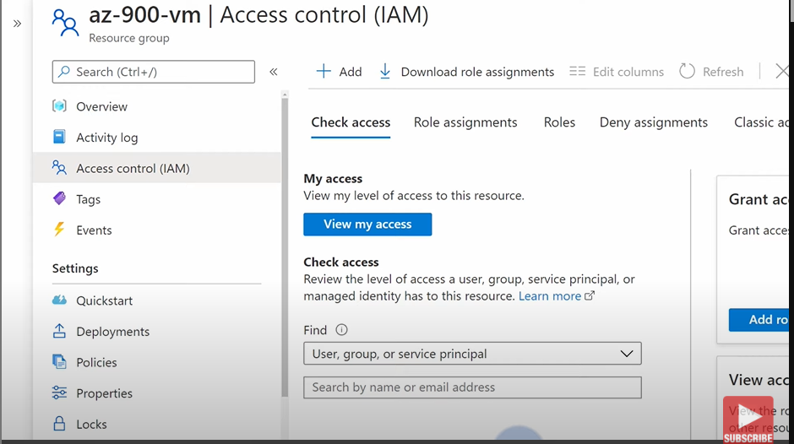

**At IAM, you can do all the stuff such as create roles, assign roles and more.**

**This IAM, you can find under all the azure resources. From this you will be able to see who has what permissions. From here you can also provide access and revoke access.**

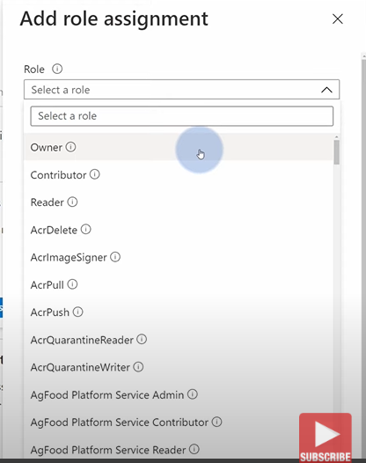

**Summary:**

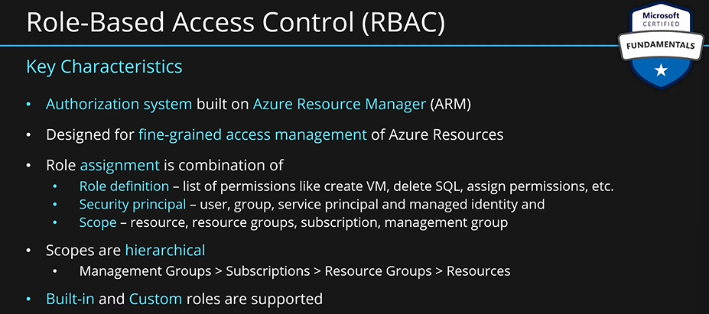

### Describe the concept of Zero Trust.

**Describe zero trust model:**

Zero Trust is a security model that assumes the worst-case scenario and protects resources with that expectation. Zero Trust assumes breach at the outset, and then verifies each request as though it originated from an uncontrolled network.

Today, organizations need a new security model that effectively adapts to the complexity of the modern environment; embraces the mobile workforce: and protects people, devices, applications, and data wherever they're located.

To address this new world of computing, Microsoft highly recommends the Zero Trust security model, which is based on these guiding principles:

* **Verify explicitly** - Always authenticate and authorize based on all available data points.
* **Use least privilege access** - Limit user access with Just-In-Time and Just-Enough-Access (JIT/JEA), risk-based adaptive policies, and data protection.
* **Assume breach** - Minimize blast radius and segment access. Verify end-to-end encryption. Use analytics to get visibility, drive threat detection, and improve defenses.

**Adjusting to Zero Trust**

Traditionally, corporate networks were restricted, protected, and generally assumed safe. Only managed computers could join the network, VPN access was tightly controlled, and personal devices were frequently restricted or blocked.

The Zero Trust model flips that scenario. Instead of assuming that a device is safe because it’s within the corporate network, it requires everyone to authenticate. Then grants access based on authentication rather than location.

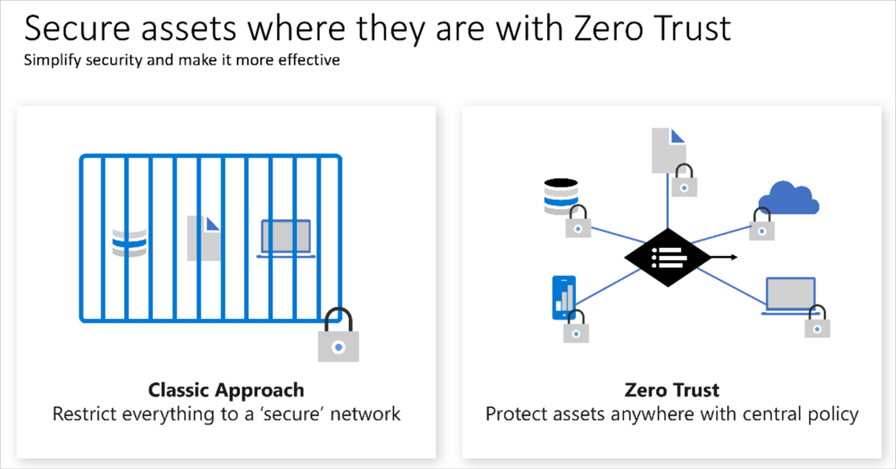

### Describe the purpose of the defense-in-depth model.

**Describe defense-in-depth:**

The objective of defense-in-depth is to protect information and prevent it from being stolen by those who aren't authorized to access it.

A defense-in-depth strategy uses a series of mechanisms to slow the advance of an attack that aims at acquiring unauthorized access to data.

**Layers of defense-in-depth**

You can visualize defense-in-depth as a set of layers, with the data to be secured at the center and all the other layers functioning to protect that central data layer.

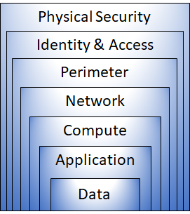

Each layer provides protection so that if one layer is breached, a subsequent layer is already in place to prevent further exposure. This approach removes reliance on any single layer of protection. It slows down an attack and provides alert information that security teams can act upon, either automatically or manually.

Here's a brief overview of the role of each layer:

* The physical security layer is the first line of defense to protect computing hardware in the datacenter.
* The identity and access layer controls access to infrastructure and change control.
* The perimeter layer uses distributed denial of service (DDoS) protection to filter large-scale attacks before they can cause a denial of service for users.
* The network layer limits communication between resources through segmentation and access controls.
* The compute layer secures access to virtual machines.
* The application layer helps ensure that applications are secure and free of security vulnerabilities.
* The data layer controls access to business and customer data that you need to protect.

These layers provide a guideline for you to help make security configuration decisions in all of the layers of your applications.

Azure provides security tools and features at every level of the defense-in-depth concept. Let's take a closer look at each layer:

**Physical security**

Physically securing access to buildings and controlling access to computing hardware within the datacenter are the first line of defense.

With physical security, the intent is to provide physical safeguards against access to assets. These safeguards ensure that other layers can't be bypassed, and loss or theft is handled appropriately. Microsoft uses various physical security mechanisms in its cloud datacenters.

**Identity and access**

The identity and access layer is all about ensuring that identities are secure, that access is granted only to what's needed, and that sign-in events and changes are logged.

At this layer, it's important to:

* Control access to infrastructure and change control.
* Use single sign-on (SSO) and multifactor authentication.
* Audit events and changes.

**Perimeter**

The network perimeter protects from network-based attacks against your resources. Identifying these attacks, eliminating their impact, and alerting you when they happen are important ways to keep your network secure.

At this layer, it's important to:

* Use DDoS protection to filter large-scale attacks before they can affect the availability of a system for users.
* Use perimeter firewalls to identify and alert on malicious attacks against your network.

**Network**

At this layer, the focus is on limiting the network connectivity across all your resources to allow only what's required. By limiting this communication, you reduce the risk of an attack spreading to other systems in your network.

At this layer, it's important to:

* Limit communication between resources.
* Deny by default.
* Restrict inbound internet access and limit outbound access where appropriate.
* Implement secure connectivity to on-premises networks.

**Compute**

Malware, unpatched systems, and improperly secured systems open your environment to attacks. The focus in this layer is on making sure that your compute resources are secure and that you have the proper controls in place to minimize security issues.

At this layer, it's important to:

* Secure access to virtual machines.
* Implement endpoint protection on devices and keep systems patched and current.

**Application**

Integrating security into the application development lifecycle helps reduce the number of vulnerabilities introduced in code. Every development team should ensure that its applications are secure by default.

At this layer, it's important to:

* Ensure that applications are secure and free of vulnerabilities.
* Store sensitive application secrets in a secure storage medium.
* Make security a design requirement for all application development.

**Data**

Those who store and control access to data are responsible for ensuring that it's properly secured. Often, regulatory requirements dictate the controls and processes that must be in place to ensure the confidentiality, integrity, and availability of the data.

In almost all cases, attackers are after data:

* Stored in a database.
* Stored on disk inside virtual machines.
* Stored in software as a service (SaaS) applications, such as Office 365.
* Managed through cloud storage.

### Describe the purpose of Microsoft Defender for Cloud.

**Microsoft Defender for Cloud:**

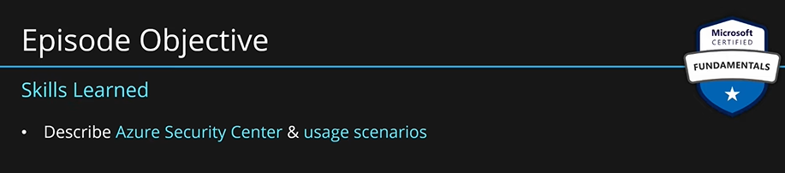

**Microsoft Defender for Cloud** **(formerly known as Azure Security Center)** continuously scans your azure services, it could be IaaS or PaaS etc., and helps you protect your azure environment. Security center also gives recommendations to admins and developers, they can work on them and protect their environment themselves.

You can also install security center’s agents on on-premises VMs to extend its functionality to protect your hybrid cloud environment.

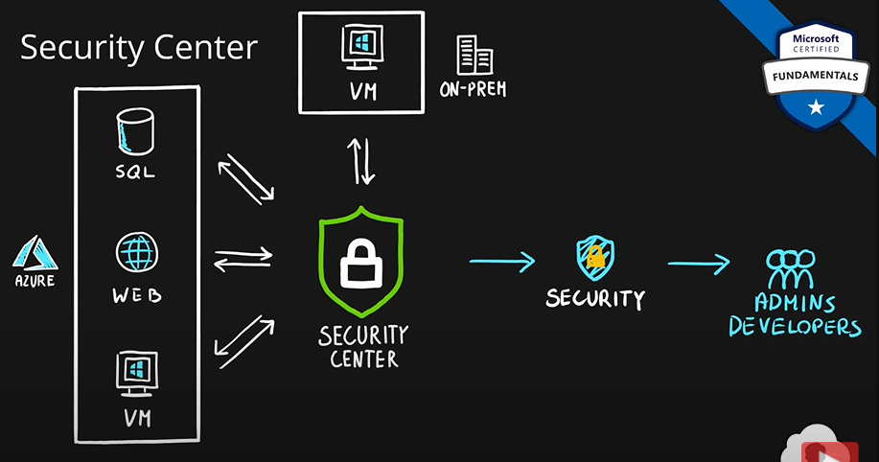

**Describe Microsoft Defender for Cloud:**

Defender for Cloud is a monitoring tool for security posture management and threat protection. It monitors your cloud, on-premises, hybrid, and multi-cloud environments to provide guidance and notifications aimed at strengthening your security posture.

Defender for Cloud provides the tools needed to harden your resources, track your security posture, protect against cyber-attacks, and streamline security management. Deployment of Defender for Cloud is easy, it’s already natively integrated to Azure.

Protection everywhere you’re deployed:

Because Defender for Cloud is an Azure-native service, many Azure services are monitored and protected without needing any deployment. However, if you also have an on-premises datacenter or are also operating in another cloud environment, monitoring of Azure services may not give you a complete picture of your security situation.

When necessary, Defender for Cloud can automatically deploy a Log Analytics agent to gather security-related data. For Azure machines, deployment is handled directly. For hybrid and multi-cloud environments, Microsoft Defender plans are extended to non-Azure machines with the help of Azure Arc. Cloud security posture management (CSPM) features are extended to multi-cloud machines without the need for any agents.

**Azure-native protections**

**Defender for Cloud helps you detect threats across:**

* **Azure PaaS services** – Detect threats targeting Azure services including Azure App Service, Azure SQL, Azure Storage Account, and more data services. You can also perform anomaly detection on your Azure activity logs using the native integration with Microsoft Defender for Cloud Apps (formerly known as Microsoft Cloud App Security).
* **Azure data services** – Defender for Cloud includes capabilities that help you automatically classify your data in Azure SQL. You can also get assessments for potential vulnerabilities across Azure SQL and Storage services, and recommendations for how to mitigate them.
* **Networks** – Defender for Cloud helps you limit exposure to brute force attacks. By reducing access to virtual machine ports, using the just-in-time VM access, you can harden your network by preventing unnecessary access. You can set secure access policies on selected ports, for only authorized users, allowed source IP address ranges or IP addresses, and for a limited amount of time.

**Defend your hybrid resources:**

In addition to defending your Azure environment, you can add Defender for Cloud capabilities to your hybrid cloud environment to protect your non-Azure servers. To help you focus on what matters the most, you'll get customized threat intelligence and prioritized alerts according to your specific environment.

To extend protection to on-premises machines, deploy Azure Arc and enable Defender for Cloud's enhanced security features.

**Defend resources running on other clouds:**

Defender for Cloud can also protect resources in other clouds (such as AWS and GCP).

For example, if you've connected an Amazon Web Services (AWS) account to an Azure subscription, you can enable any of these protections:

* Defender for Cloud's CSPM features extend to your AWS resources. This agentless plan assesses your AWS resources according to AWS-specific security recommendations and includes the results in the secure score. The resources will also be assessed for compliance with built-in standards specific to AWS (AWS CIS, AWS PCI DSS, and AWS Foundational Security Best Practices). Defender for Cloud's asset inventory page is a multi-cloud enabled feature helping you manage your AWS resources alongside your Azure resources.
* Microsoft Defender for Containers extends its container threat detection and advanced defenses to your Amazon EKS Linux clusters.
* Microsoft Defender for Servers brings threat detection and advanced defenses to your Windows and Linux EC2 instances.

**Assess, Secure, and Defend:**

Defender for Cloud fills three vital needs as you manage the security of your resources and workloads in the cloud and on-premises:

**Continuously assess** – Know your security posture. Identify and track vulnerabilities.

**Secure** – Harden resources and services with Azure Security Benchmark.

**Defend** – Detect and resolve threats to resources, workloads, and services.

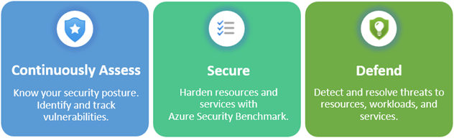

**Continuously assess:**

Defender for cloud helps you continuously assess your environment. Defender for Cloud includes vulnerability assessment solutions for your virtual machines, container registries, and SQL servers.

Microsoft Defender for servers includes automatic, native integration with Microsoft Defender for Endpoint. With this integration enabled, you'll have access to the vulnerability findings from Microsoft threat and vulnerability management.

Between these assessment tools you’ll have regular, detailed vulnerability scans that cover your compute, data, and infrastructure. You can review and respond to the results of these scans all from within Defender for Cloud.

**Secure**

From authentication methods to access control to the concept of Zero Trust, security in the cloud is an essential basic that must be done right. In order to be secure in the cloud, you have to ensure your workloads are secure. To secure your workloads, you need security policies in place that are tailored to your environment and situation. Because policies in Defender for Cloud are built on top of Azure Policy controls, you’re getting the full range and flexibility of a world-class policy solution. In Defender for Cloud, you can set your policies to run on management groups, across subscriptions, and even for a whole tenant.

One of the benefits of moving to the cloud is the ability to grow and scale as you need, adding new services and resources as necessary. Defender for Cloud is constantly monitoring for new resources being deployed across your workloads. Defender for Cloud assesses if new resources are configured according to security best practices. If not, they're flagged, and you get a prioritized list of recommendations for what you need to fix. Recommendations help you reduce the attack surface across each of your resources.

The list of recommendations is enabled and supported by the Azure Security Benchmark. This Microsoft-authored, Azure-specific, benchmark provides a set of guidelines for security and compliance best practices based on common compliance frameworks.

In this way, Defender for Cloud enables you not just to set security policies, but to apply secure configuration standards across your resources.

To help you understand how important each recommendation is to your overall security posture, Defender for Cloud groups the recommendations into security controls and adds a secure score value to each control. The secure score gives you an at-a-glance indicator of the health of your security posture, while the controls give you a working list of things to consider improving your security score and your overall security posture.

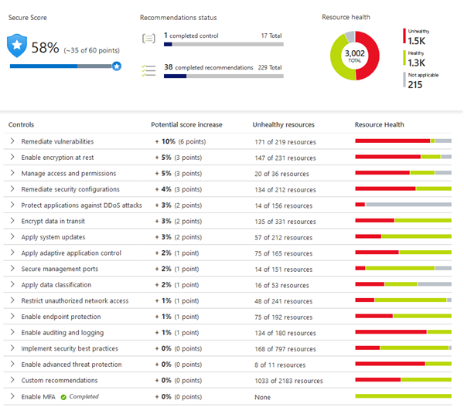

**Defend**

The first two areas were focused on assessing, monitoring, and maintaining your environment. Defender for Cloud also helps you defend your environment by providing security alerts and advanced threat protection features.

**Security alerts**

When Defender for Cloud detects a threat in any area of your environment, it generates a security alert. Security alerts:

* Describe details of the affected resources
* Suggest remediation steps
* Provide, in some cases, an option to trigger a logic app in response

Whether an alert is generated by Defender for Cloud or received by Defender for Cloud from an integrated security product, you can export it. Defender for Cloud's threat protection includes fusion kill-chain analysis, which automatically correlates alerts in your environment based on cyber kill-chain analysis, to help you better understand the full story of an attack campaign, where it started, and what kind of impact it had on your resources.

**Advanced threat protection**

Defender for cloud provides advanced threat protection features for many of your deployed resources, including virtual machines, SQL databases, containers, web applications, and your network. Protections include securing the management ports of your VMs with just-in-time access, and adaptive application controls to create allowlists for what apps should and shouldn't run on your machines.

# Describe Azure management and governance (30–35%)

## Describe Azure management and governance.

### Describe factors that can affect costs in Azure.

Azure shifts development costs from the **capital expense (CapEx)** of building out and maintaining infrastructure and facilities to an **operational expense (OpEx)** of renting infrastructure as you need it, whether it’s compute, storage, networking, and so on.

That OpEx cost can be impacted by many factors. Some of the impacting factors are:

* Resource type
* Consumption
* Maintenance
* Geography
* Subscription type
* Azure Marketplace

**Resource type**

A number of factors influence the cost of Azure resources. The type of resources, the settings for the resource, and the Azure region will all have an impact on how much a resource costs. When you provision an Azure resource, Azure creates metered instances for that resource. The meters track the resources' usage and generate a usage record that is used to calculate your bill.

**Examples**

**With a storage account,** you specify a type such as blob, a performance tier, an access tier, redundancy settings, and a region. Creating the same storage account in different regions may show different costs and changing any of the settings may also impact the price.

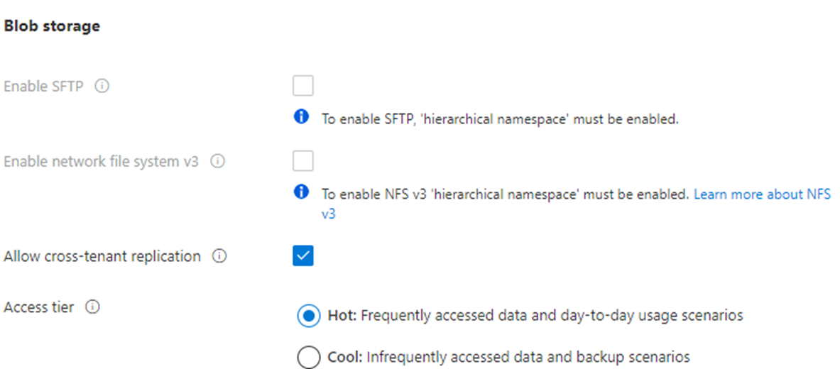

**With a virtual machine (VM),** you may have to consider licensing for the operating system or other software, the processor and number of cores for the VM, the attached storage, and the network interface. Just like with storage, provisioning the same virtual machine in different regions may result in different costs.

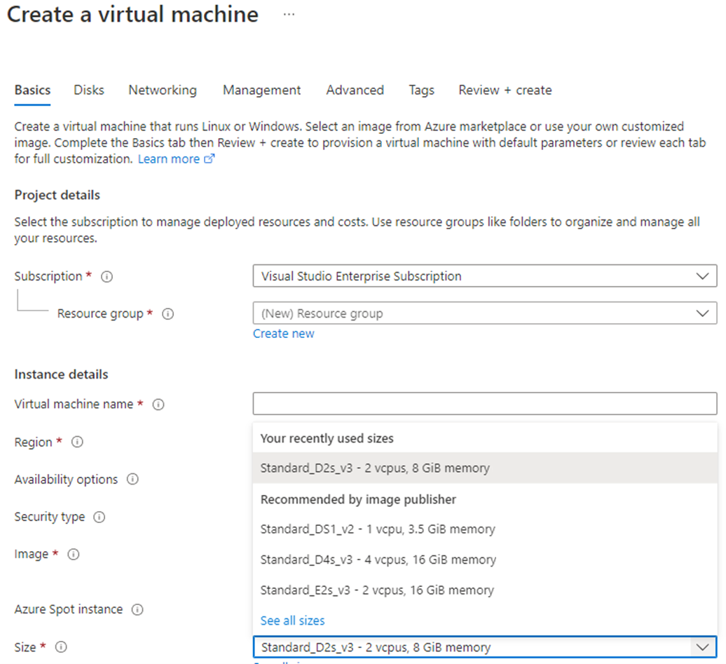

**Consumption**

Pay-as-you-go has been a consistent theme throughout, and that’s the cloud payment model where you pay for the resources that you use during a billing cycle. If you use more compute this cycle, you pay more. If you use less in the current cycle, you pay less. It’s a straight forward pricing mechanism that allows for maximum flexibility.

However, Azure also offers the ability to commit to using a set amount of cloud resources in advance and receiving discounts on those “reserved” resources. Many services, including databases, compute, and storage all provide the option to commit to a level of use and receive a discount, in some cases up to 72 percent.

When you reserve capacity, you’re committing to using and paying for a certain amount of Azure resources during a given period (typically one or three years). With the back-up of pay-as-you-go, if you see a sudden surge in demand that eclipses what you’ve pre-reserved, you just pay for the additional resources in excess of your reservation. This model allows you to recognize significant savings on reliable, consistent workloads while also having the flexibility to rapidly increase your cloud footprint as the need arises.

**Maintenance**

The flexibility of the cloud makes it possible to rapidly adjust resources based on demand. Using resource groups can help keep all of your resources organized. In order to control costs, it’s important to maintain your cloud environment. For example, every time you provision a VM, additional resources such as storage and networking are also provisioned. If you deprovision the VM, those additional resources may not deprovision at the same time, either intentionally or unintentionally. By keeping an eye on your resources and making sure you’re not keeping around resources that are no longer needed, you can help control cloud costs.

**Geography**

When you provision most resources in Azure, you need to define a region where the resource deploys. Azure infrastructure is distributed globally, which enables you to deploy your services centrally or closest to your customers, or something in between. With this global deployment comes global pricing differences. The cost of power, labor, taxes, and fees vary depending on the location. Due to these variations, Azure resources can differ in costs to deploy depending on the region.

Network traffic is also impacted based on geography. For example, it’s less expensive to move information within Europe than to move information from Europe to Asia or South America.

**Network Traffic**

Billing zones are a factor in determining the cost of some Azure services.

Bandwidth refers to data moving in and out of Azure datacenters. Some inbound data transfers (data going into Azure datacenters) are free. For outbound data transfers (data leaving Azure datacenters), data transfer pricing is based on zones.

A zone is a geographical grouping of Azure regions for billing purposes. The bandwidth pricing page has additional information on pricing for data ingress, egress, and transfer.

**Subscription type**

Some Azure subscription types also include usage allowances, which affect costs.

For example, an Azure free trial subscription provides access to a number of Azure products that are free for 12 months. It also includes credit to spend within your first 30 days of sign-up. You'll get access to more than 25 products that are always free (based on resource and region availability).

**Azure Marketplace**

Azure Marketplace lets you purchase Azure-based solutions and services from third-party vendors. This could be a server with software preinstalled and configured, or managed network firewall appliances, or connectors to third-party backup services. When you purchase products through Azure Marketplace, you may pay for not only the Azure services that you’re using, but also the services or expertise of the third-party vendor. Billing structures are set by the vendor.

All solutions available in Azure Marketplace are certified and compliant with Azure policies and standards. The certification policies may vary based on the service or solution type and Azure service involved. Commercial marketplace certification policies have additional information on Azure Marketplace certifications.

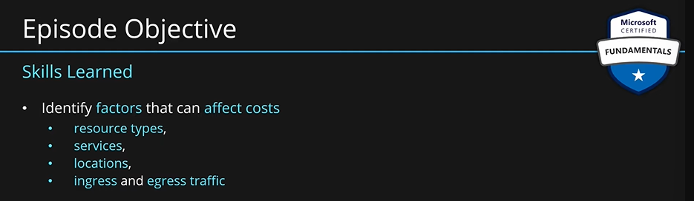

**Resource Types: What kind of service do we use?**

When you buy any service in azure, there are certain metrics that track the usage of your virtual machine. If you buy a VM, you specify how much CPU/processor, RAM/memory. Then these metrics are tracked again the uptime. This means that for how long you had your VM with this configuration.

For SQL Server, you pay for CPU, memory, storage. Then these metrics are tracked again the uptime.

There are other services with much more flexible pricing. In azure functions you pay for how many times you executed your piece of code/function and how much memory did that consume per sec.

For storage account, you pay for how much storage you are consuming and what access tier that storage is and how many operations you are doing on this storage account.

For logic apps, you pay for how many actions you executed.

Logical resources such as resource groups are free. They are not services. They are just logical objects.

**Every resource type has a small metric that is tracking your usage. This is the key factor that will affect the final cost of your azure environment.**

Always spend time on what kind of use case you have, what kind of application you are building, which are the right resource types for you.

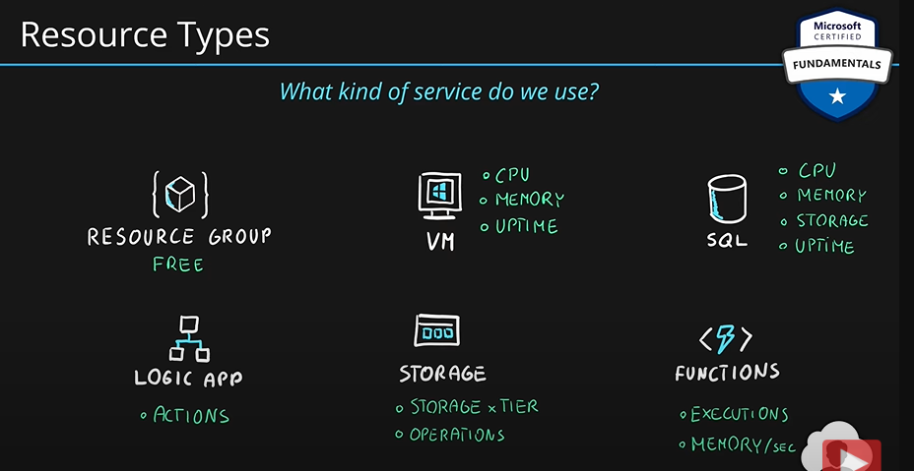

**Services:** Different services offerings of azure also have different pricing. **What kind of offer do you have? How did you purchase your azure?**

Customers can buy azure in multiple ways:

1. **Web Portal:** 
   1. Azure Free: Great for testing
   2. Pay as you go: Billed monthly for your azure usage.
   3. MPN: You get some azure credits from MS partner networks
   4. Visual Studio
   5. More
2. **MS Representative:** You can contact MS representative and buy an enterprise agreement. This is an agreement between MS and your company. A contract that you sign.
3. **MS partner called Cloud Solution Provider (CSP).**

Based on which offer type you have; two things are affected:

1. **Usage Rate:** Cost of azure services. With CSP and enterprise agreement, you can negotiate the prices.
2. **Billing Cycle.**

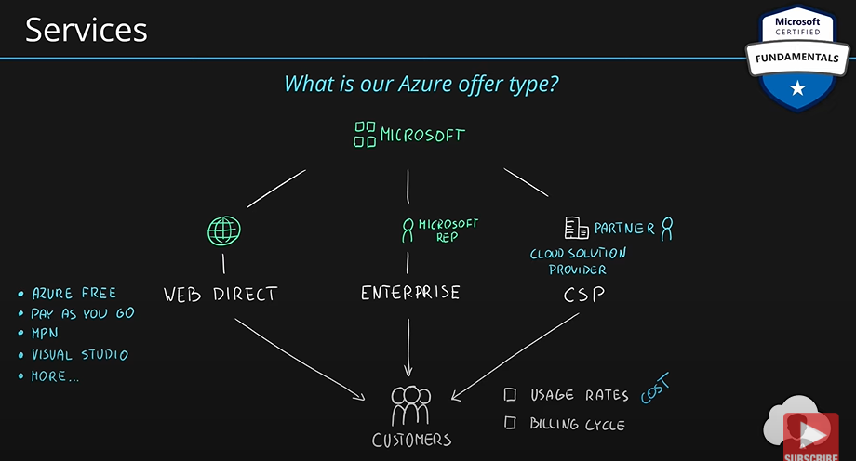

**Locations:** Where are your services based? This affects the price greatly.

Let’s say you bought a VM with four cores and 4GB RAM in south Europe. Azure pricing calculator says it will cost you 100$ a month. If now, you change region and pick VM with the exact same configuration in north Europe then pricing may differ. Same configurations, same resource type, same azure offer, still the price is different due to different location.

Simply, cost of running azure data center differs from region to region. Hence pricing also differs.

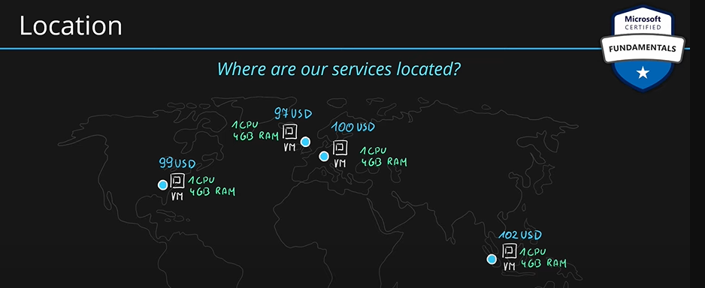

Keep these things in mind when picking a region for your application:

1. Pick region closest to your users. So, latency is small.
2. Region with all the services that you need.
3. Region with lowest price for your services.

**Bandwidth/Traffic: How much data we move in and out of azure?**

When we adopt cloud, we will migrate data from our data center to azure. We will upload data to azure. Upload is called **ingress or inbound traffic.** When we download data from azure, we call it **egress or outbound traffic.** In most cases, the inbound traffic is free (moving data to azure). Outbound traffic is not free. There are a lot of factors affecting the pricing when it comes to bandwidth. We can read more about it on azure pricing page.

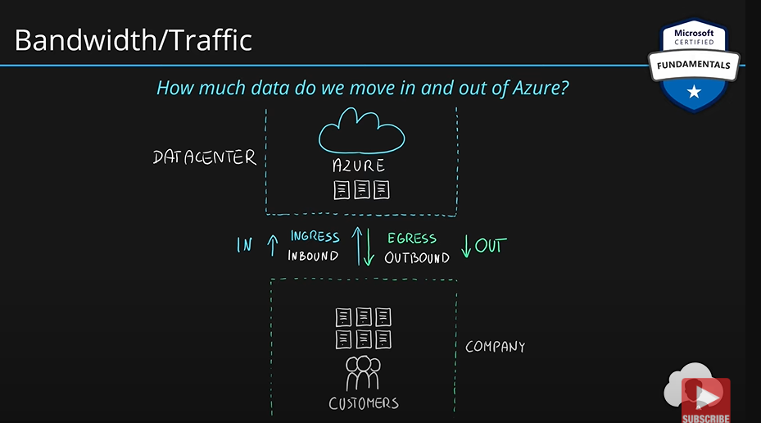

**Summary:**

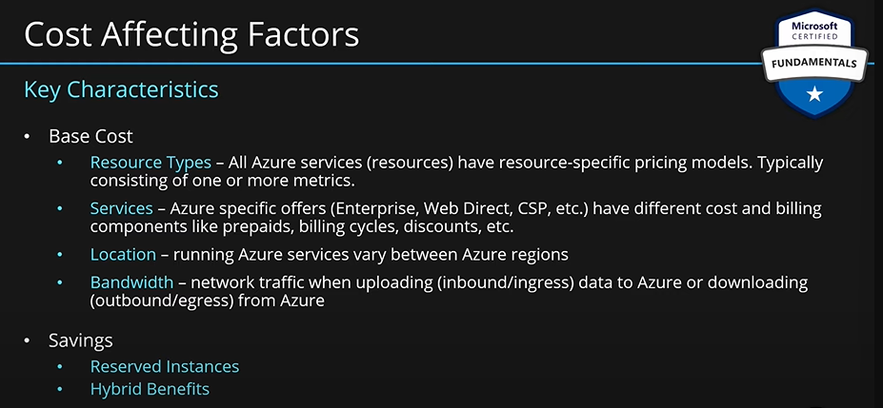

**The pricing calculator and the total cost of ownership (TCO) calculator are two calculators that help you understand potential Azure expenses. Both calculators are accessible from the internet, and both calculators allow you to build out a configuration. However, the two calculators have very different purposes.**

### Compare the pricing calculator and the Total Cost of Ownership (TCO) Calculator.

**Cost Reduction Methods, Pricing & TCO Calculator**

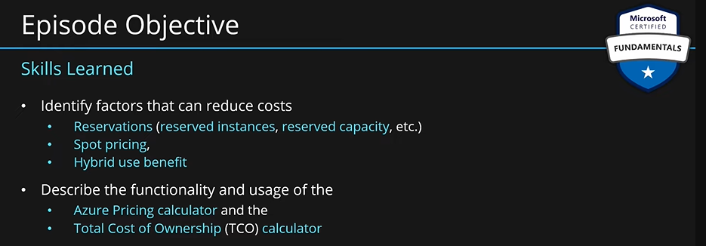

**Reservations:** When you buy a VM in azure, you only pay for the usage of the VM. You pick a VM with a specific capacity i.e. SKUs, 1 core, 2 core or more. You are only charged for the time machine is running. Also, this VM can scale up and down as well based on load.

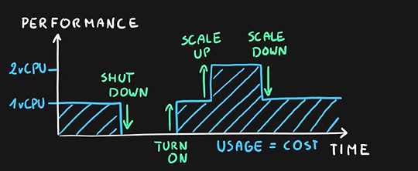

Let’s say you have a workload which does not need the benefits mentioned above. You might have a very stable workload which will constantly consume one virtual core of that VM for a long time. You don’t need to shut down this machine. You also don’t need to scale up or down. Now, you have a specific use case. You can reduce the cost of your resource for this case using **azure reservation.**

Let’s say we buy a VM with one core: Cost = 50$/Month

For a week: Cost = 12$

For a year: Cost = 600$ (If you use the VM constantly)

Azure provides you a feature using which you can reserve this VM for a period and get a discount for that.

For a year, VM with one core (with azure reservation): 360$

Per month: 30$ 🡪 40% discount

You can also do reservations for a longer period of time such as 3 years etc.

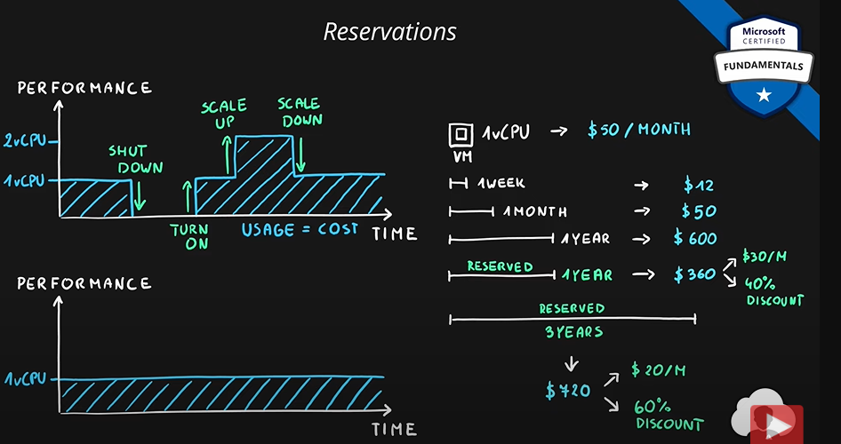

This can save you a lot of money if you have a stable workload in large environments which rely on certain services running all the time. These services can make use of the reservations.

Three types of reservations:

1. **Reserved Instances:** Reserve the SKUs or compute power of the machines such as VM.
2. **Reserved Capacity:** Reserve capacity of PaaS services such as azure storage, SQL database vCores, Databricks DBUs, Cosmos DB RUs etc.
3. **Software Plans:** Red Hat, Red Hat OpenShift, SUSE Linux, etc. This means reserving the licensing costs for operating systems.

Note: Reservations are made for 1 or 3 years.

**Spot VMs:**

MS will always have many unused VM capacity in their datacenters. You can use this unused capacity by using spot VMs. You can buy a spot VM at a significant discount. If MS needs this VM capacity (maybe some other VM is scaling up or anything else) then you will lose this machine without any notice.

Depending on the unused capacity at MS datacenters, the price of the spot VM will change. If the unused capacity is high, the price of the spot VM will be low and vice versa.

**How it works:**

1. You buy a spot VM at a significant discount.
2. MS can take away this VM at any time without any notice.

Price changes based on the unused capacity. You can set max price you are willing to pay. If the price of the VM goes above this threshold, you can evict this VM.

This service is great for interruptible workloads. For example, batch processing, dev/test environment, large compute workloads)

Make sure you only do noncritical tasks on these spot VMs.

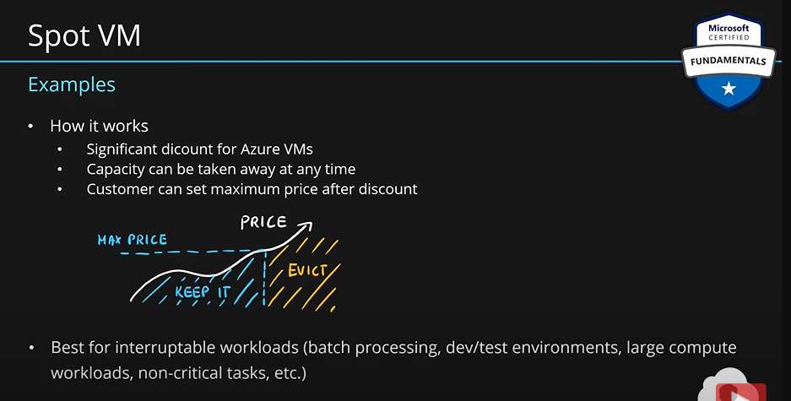

**Hybrid use Benefit:**

Imagine a scenario where you have VM in your on-premises infrastructure. This VM is running windows. You have purchased windows license. You want to migrate to cloud. In the cloud you have to pay for the compute power i.e. CPU cores etc. Here, you also have to pay for the windows licensing as well. But you already have purchased a license.

When you buy a VM and choose Windows OS, the licensing fees for Windows is also included in the price of the VM. To use your existing license, you can choose **hybrid use benefit**.

**Without hybrid use benefit:**

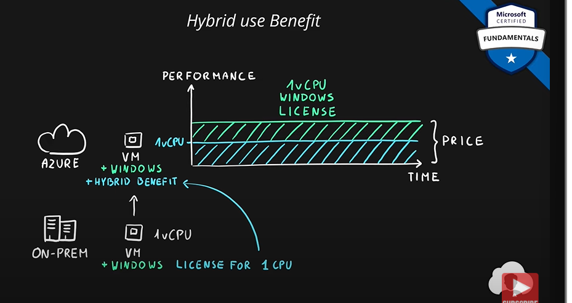

**With hybrid use benefit:**

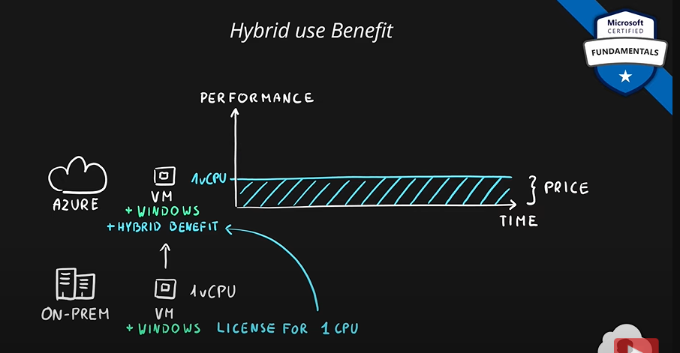

**The cost of windows licensing is removed.**

If you combine azure reservations with this feature, you can save a lot.

**Hybrid benefits** allows you to use existing licenses with cloud services.

You can save money on VMs with existing OS license, SQL Server DB with DB licenses, SQL Managed Instances and more.

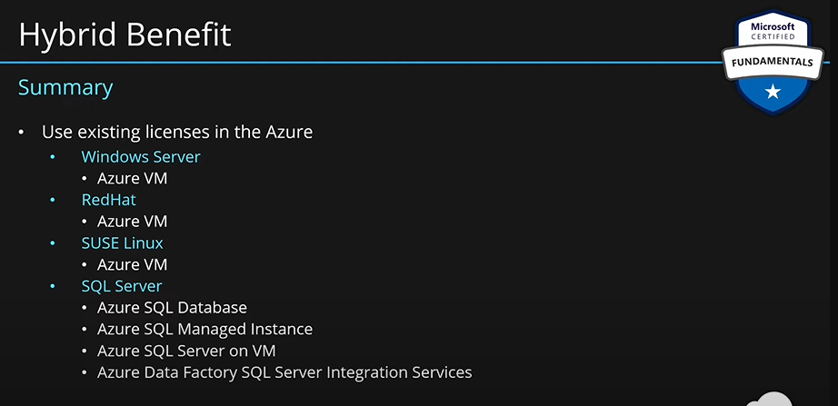

**Cost Reduction Methods:**

**The pricing calculator and the total cost of ownership (TCO) calculator are two calculators that help you understand potential Azure expenses. Both calculators are accessible from the internet, and both calculators allow you to build out a configuration. However, the two calculators have very different purposes.**

**Azure Pricing Calculator:** It provides the estimated cost of your azure environment.

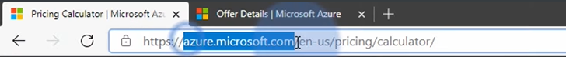

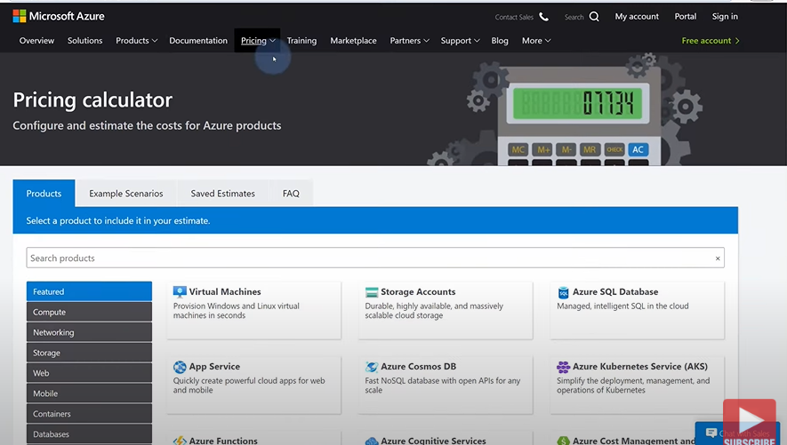

You can select services from here. Then you can select the configurations for that service. It will tell you how much cost these resources might potentially have.

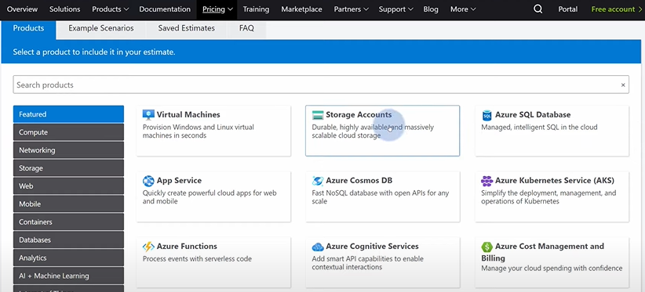

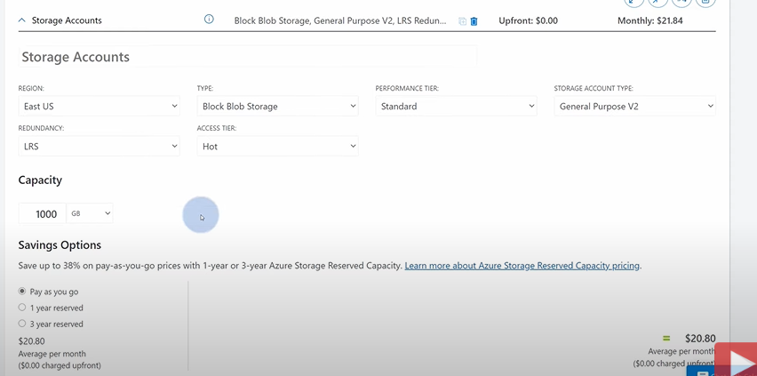

1. **Azure Pricing Calculator:**
2. **Choose the services.**
3. **Adjust variables.**
4. **Review the cost.**

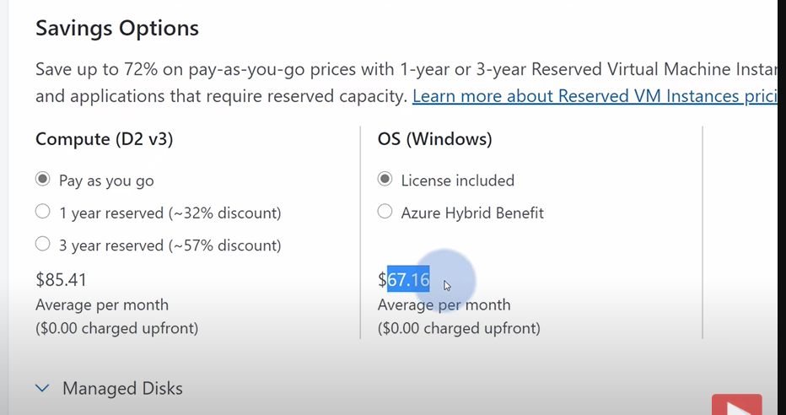

The pricing calculator is designed to give you an estimated cost for provisioning resources in Azure. You can get an estimate for individual resources, build out a solution, or use an example scenario to see an estimate of the Azure spend. The pricing calculator’s focus is on the cost of provisioned resources in Azure.

The Pricing calculator is for information purposes only. The prices are only an estimate. Nothing is provisioned when you add resources to the pricing calculator, and you won't be charged for any services you select.

With the pricing calculator, you can estimate the cost of any provisioned resources, including compute, storage, and associated network costs. You can even account for different storage options like storage type, access tier, and redundancy.

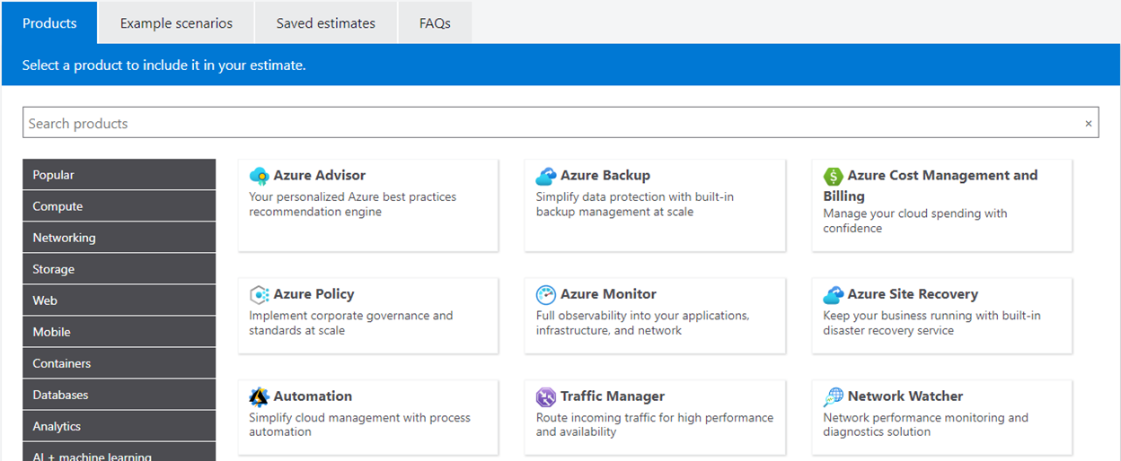

**Exercise - Estimate workload costs by using the Pricing calculator:**

In this exercise, you use the Pricing calculator to estimate the cost of running a basic web application on Azure.

Start by defining which Azure services you need.

*The Pricing calculator is for information purposes only. The prices are only an estimate, and you won't be charged for any services you select.*

**Define your requirements:**

Before you run the Pricing calculator, you need a sense of what Azure services you need.

For a basic web application hosted in your datacenter, you might run a configuration similar to the following.

An ASP.NET web application that runs on Windows. The web application provides information about product inventory and pricing. There are two virtual machines that are connected through a central load balancer. The web application connects to a SQL Server database that holds inventory and pricing information.

Here's a diagram that shows the basic configuration:

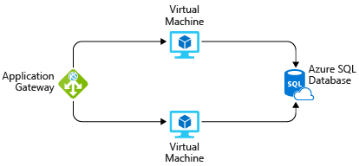

To migrate to Azure, you might:

* Use Azure Virtual Machines instances, similar to the virtual machines used in your datacenter.
* Use Azure Application Gateway for load balancing.
* Use Azure SQL Database to hold inventory and pricing information.

In practice, you would define your requirements in greater detail. But here are some basic facts and requirements to get you started:

* The application is used internally. It's not accessible to customers.
* This application doesn't require a massive amount of computing power.
* The virtual machines and the database run all the time (730 hours per month).
* The network processes about 1 TB of data per month.
* The database doesn't need to be configured for high-performance workloads and requires no more than 32 GB of storage.

**Explore the Pricing calculator:**

Let's start with a quick tour of the Pricing calculator.

* Go to the Pricing calculator.
* Notice the following tabs:

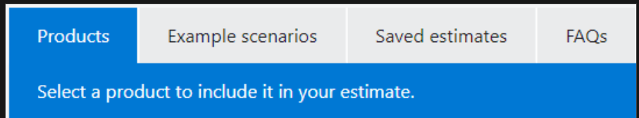

* Products This is where you choose the Azure services that you want to include in your estimate. You'll likely spend most of your time here.
* Example scenarios Here you'll find several reference architectures, or common cloud-based solutions that you can use as a starting point.
* Saved estimates Here you'll find your previously saved estimates.
* FAQs Here you'll discover answers to frequently asked questions about the Pricing calculator.

**Estimate your solution:**

Here you add each Azure service that you need to the calculator. Then you configure each service to fit your needs.

*Tip:*

*Make sure you have a clean calculator with nothing listed in the estimate. You can reset the estimate by selecting the trash can icon next to each item.*

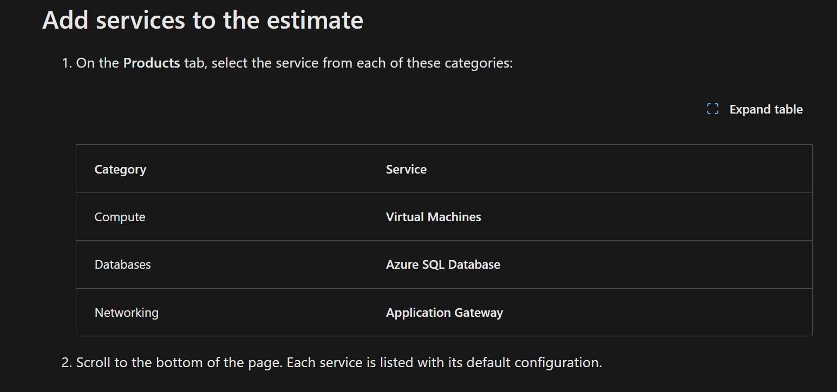

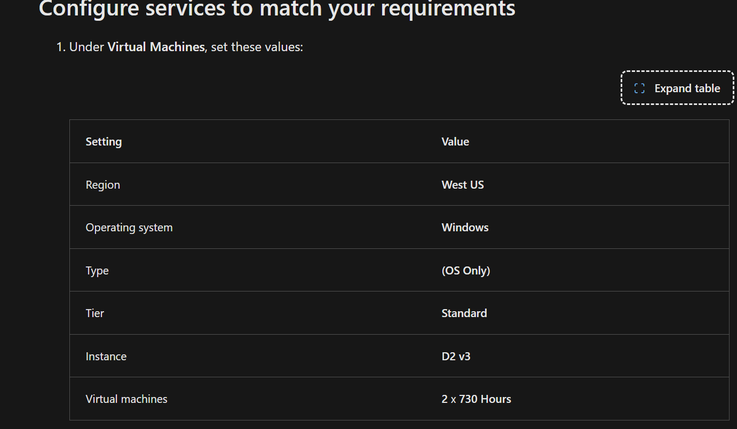

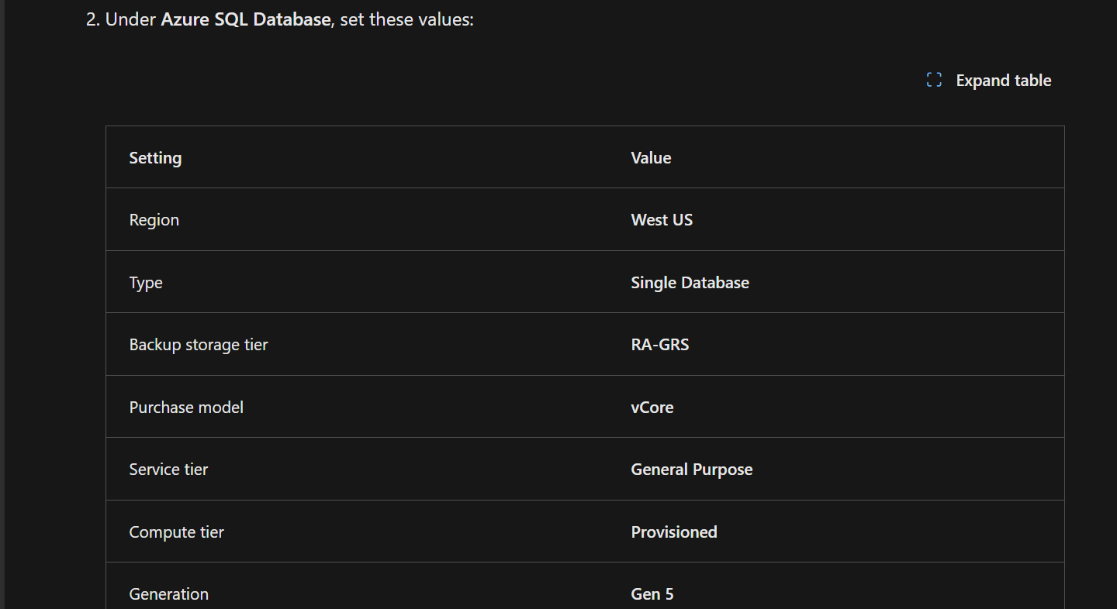

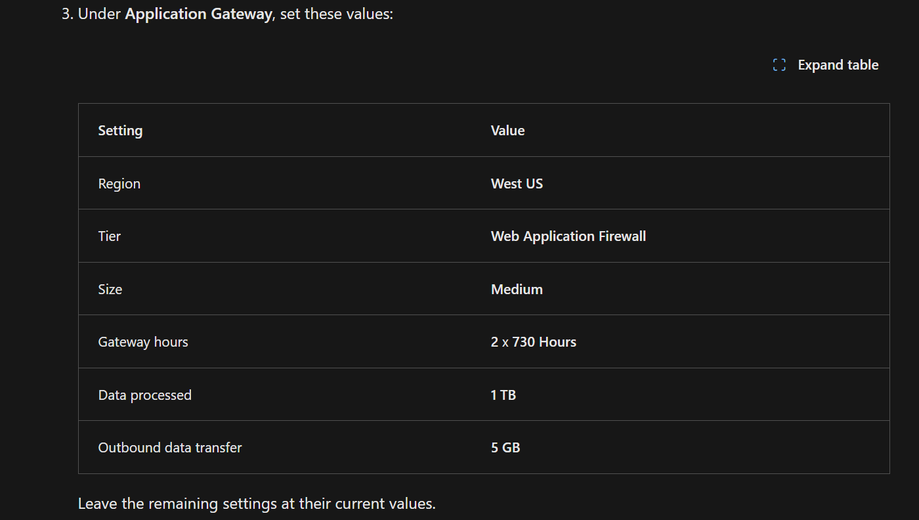

**Review, share, and save your estimate:**

At the bottom of the page, you see the total estimated cost of running the solution. You can change the currency type if you want.

At this point, you have a few options:

* Select Export to save your estimate as an Excel document.
* Select Save or Save as to save your estimate to the Saved Estimates tab for later.
* Select Share to generate a URL so you can share the estimate with your team.

You now have a cost estimate that you can share with your team. You can make adjustments as you discover any changes to your requirements.

Experiment with some of the options you worked with here or create a purchase plan for a workload you want to run on Azure.

1. **Total Cost of Ownership:**

The TCO calculator is designed to help you compare the costs for running an on-premises infrastructure compared to an Azure Cloud infrastructure. With the TCO calculator, you enter your current infrastructure configuration, including servers, databases, storage, and outbound network traffic. The TCO calculator then compares the anticipated costs for your current environment with an Azure environment supporting the same infrastructure requirements.

With the TCO calculator, you enter your configuration, add in assumptions like power and IT labor costs, and are presented with an estimation of the cost difference to run the same environment in your current datacenter or in Azure.

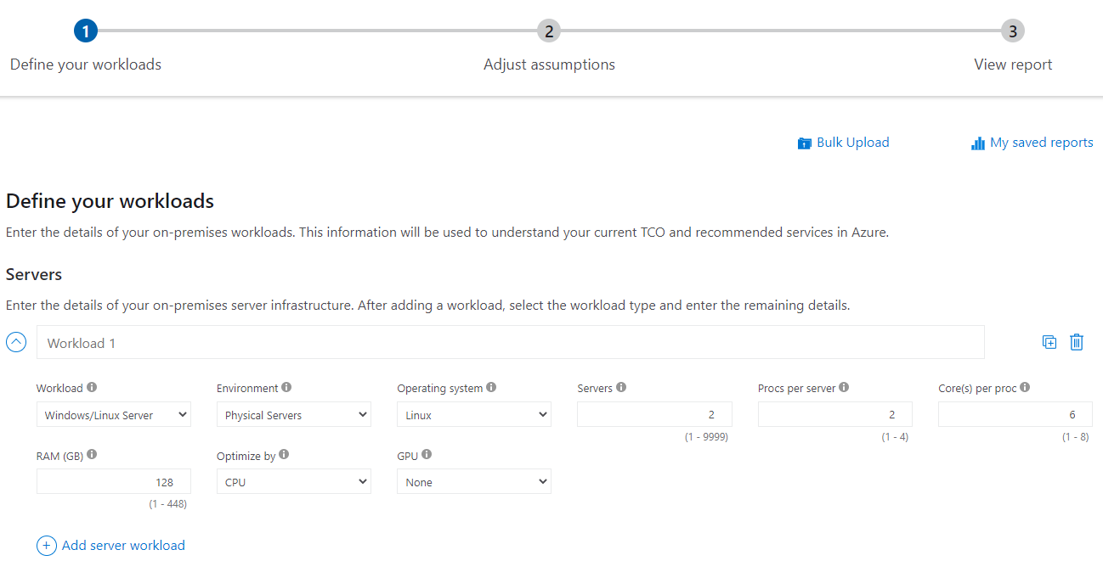

**Compares datacenter versus Azure Workloads.**

It compares the cost of running certain workloads in your own data centers on-premises verses azure.

1. **Define workloads you have in your own data centers.**
2. **Adjust assumptions, such as labor costs etc.**
3. **Review the report generated comparing the cost of running the same workload in azure vs in your own data center.**

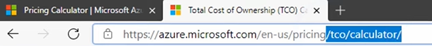

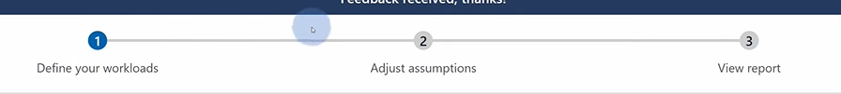

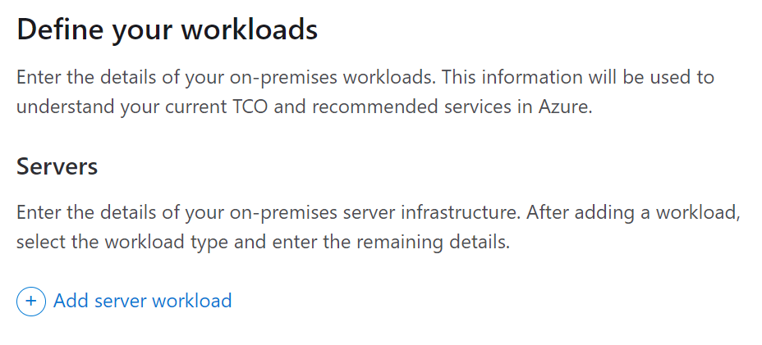

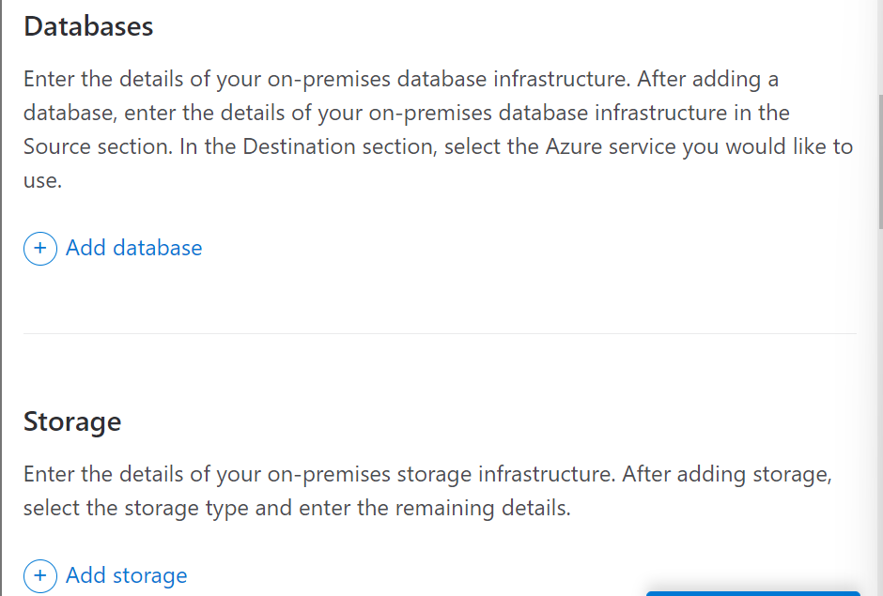

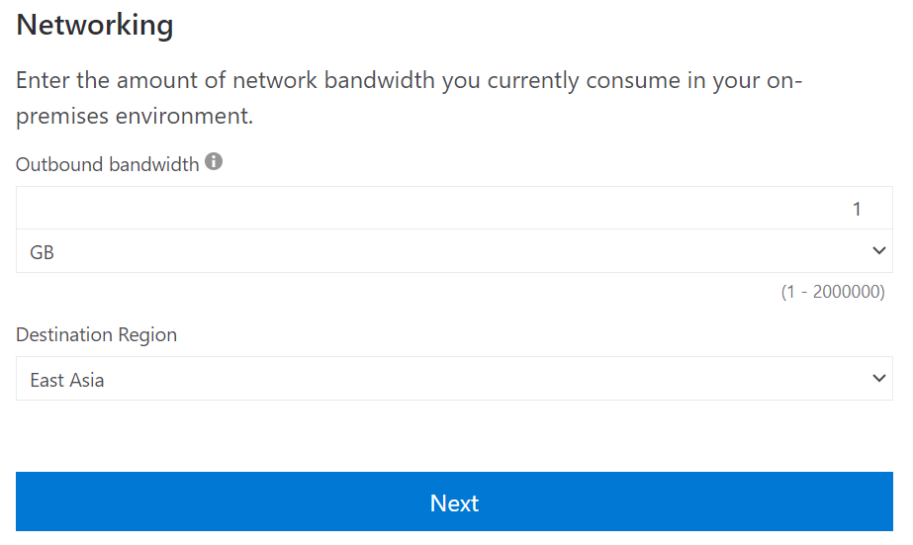

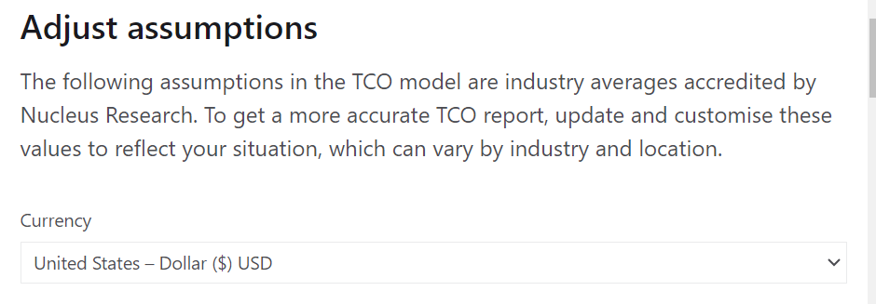 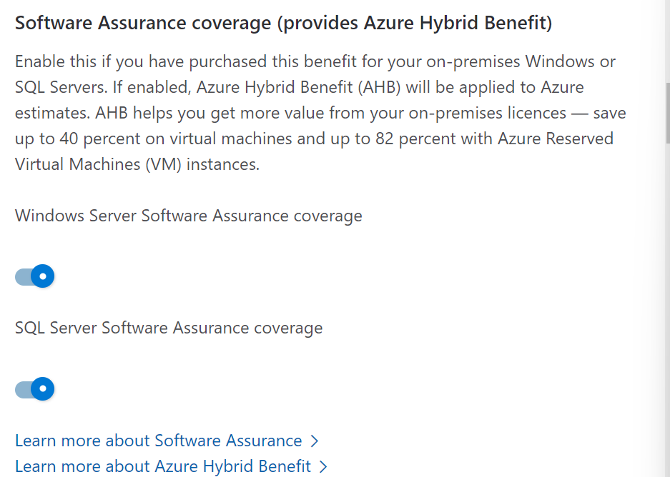 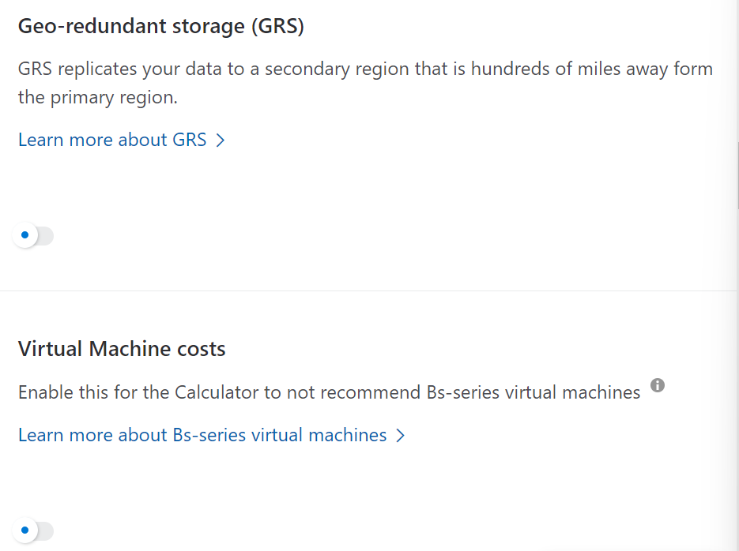 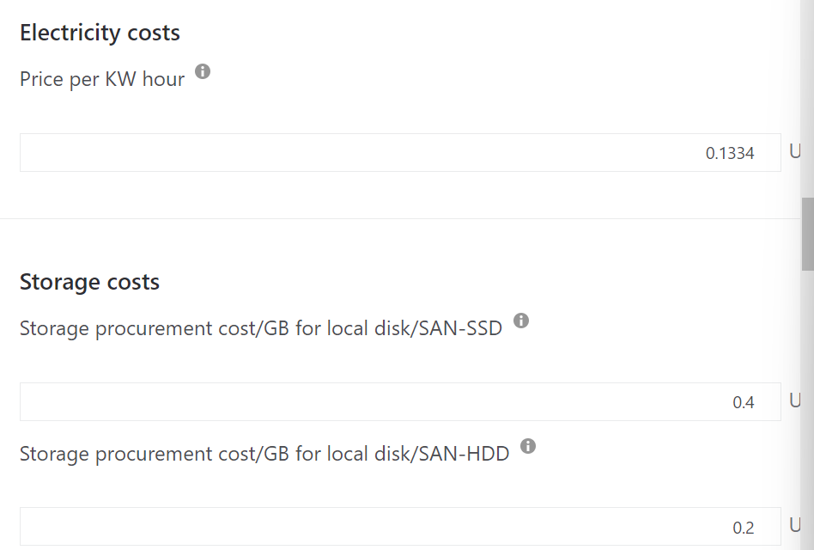 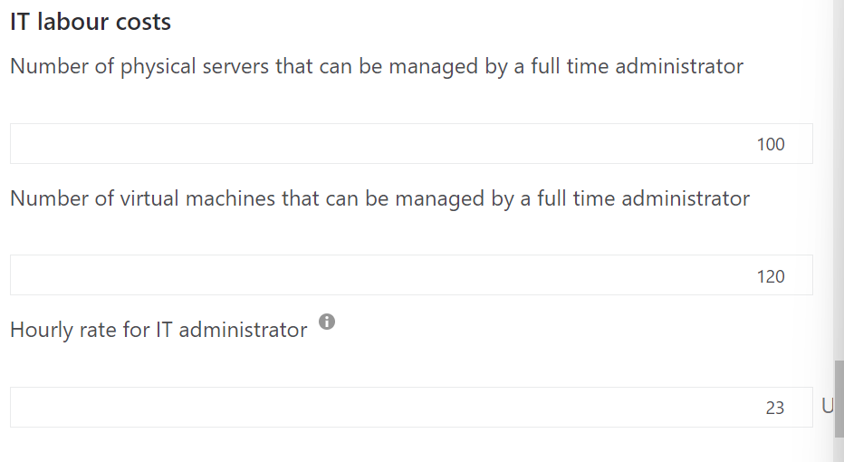 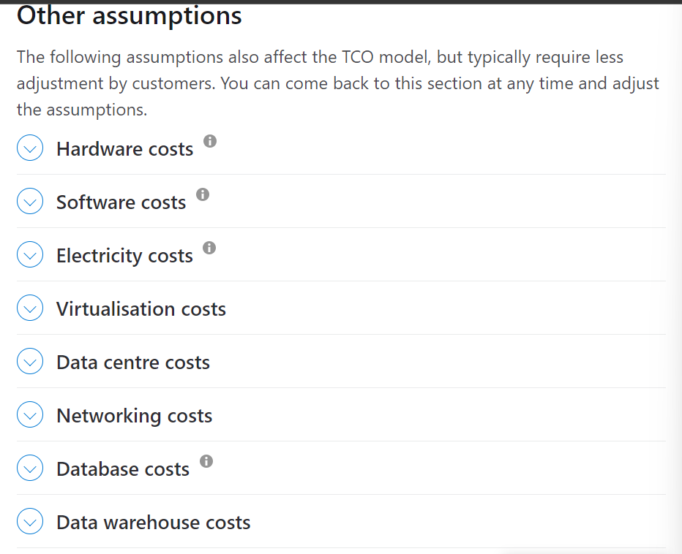

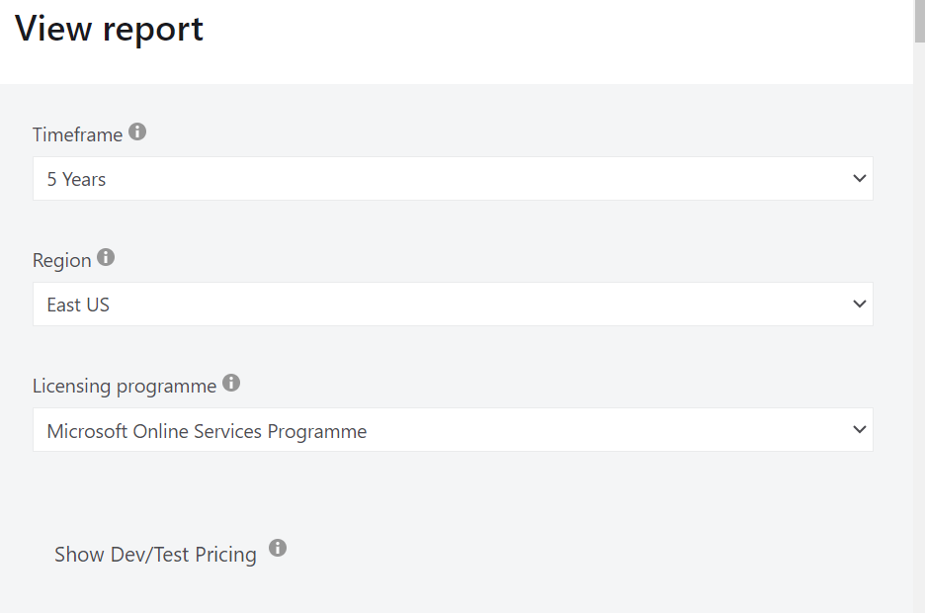

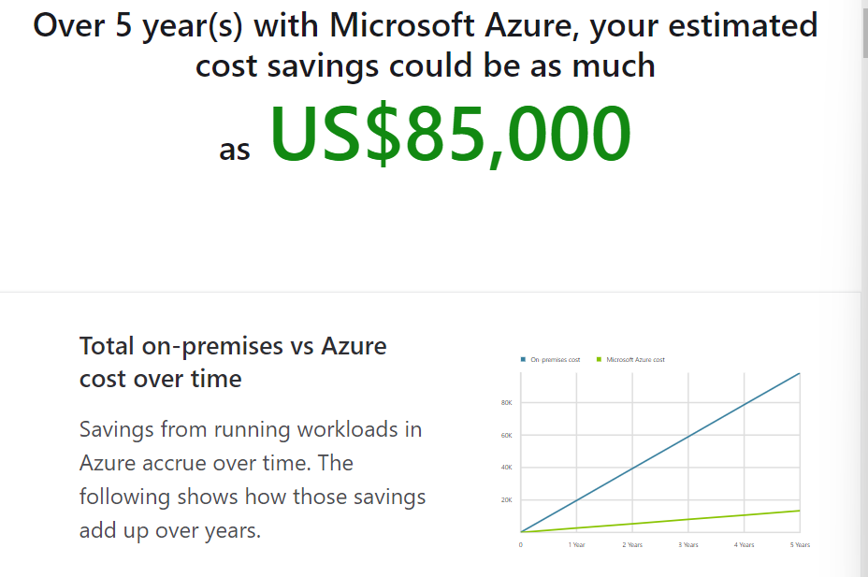 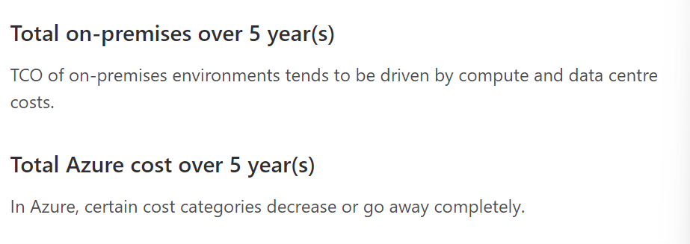 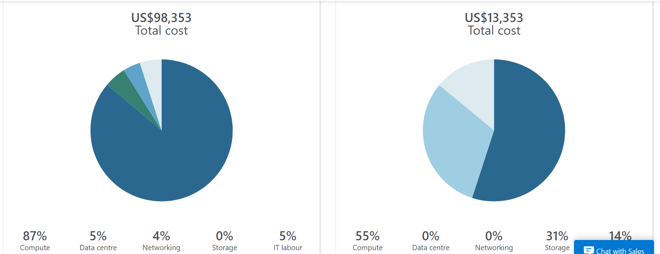

It shows savings over a period of five years.

**Exercise - Compare workload costs using the TCO calculator:**

In this exercise, you use the Total Cost of Ownership (TCO) Calculator to compare the cost of running a sample workload in your datacenter versus on Azure.

Assume you’re considering moving some of your on-premises workloads to the cloud. But first, you need to understand more about moving from a relatively fixed cost structure to an ongoing monthly cost structure.

You'll need to investigate whether there are any potential cost savings in moving your datacenter to the cloud over the next three years. You need to take into account all of the potentially hidden costs involved with operating on-premises and in the cloud.

Instead of manually collecting everything you think might be included, you use the TCO Calculator as a starting point. You adjust the provided cost assumptions to match your on-premises environment.

**Remember, you don't need an Azure subscription to work with the TCO Calculator.**

Let's say that:

* You run two sets, or banks, of 50 virtual machines (VMs) in each bank.
* The first bank of VMs runs Windows Server under Hyper-V virtualization.
* The second bank of VMs runs Linux under VMware virtualization.
* There's also a storage area network (SAN) with 60 TB of disk storage.
* You consume an estimated 15 TB of outbound network bandwidth each month.
* There are also a number of databases involved, but for now, you'll omit those details.

Recall that the TCO Calculator involves three steps:

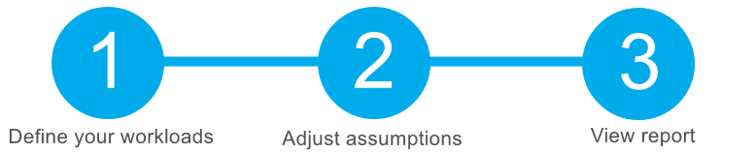

**Define your workloads**:

Enter the specifications of your on-premises infrastructure into the TCO Calculator.

* Go to the TCO Calculator.
* Under Define your workloads, select Add server workload to create a row for your bank of Windows Server VMs.
* Under Servers, set the value for each of these settings.

Setting Value

Name Servers: Windows VMs

Workload Windows/Linux Server

Environment Virtual Machines

Operating system Windows

Operating System License Datacenter

VMs 50

Virtualization Hyper-V

Core(s) 8

RAM (GB) 16

Optimize by CPU

Windows Server 2008/2008 R2 Off

* Select Add server workload to create a second row for your bank of Linux VMs. Then specify these settings:

Setting Value

Name Servers: Linux VMs

Workload Windows/Linux Server

Environment Virtual Machines

Operating system Linux

VMs 50

Virtualization VMware

Core(s) 8

RAM (GB) 16

Optimize by CPU

Under Storage, select Add storage. Then specify these settings:

Setting Value

Name Server Storage

Storage type Local Disk/SAN

Disk type HDD

Capacity 60 TB

Backup 120 TB

Archive 0 TB

* Under Networking, set Outbound bandwidth to 15 TB.
* Select Next.

**Adjust assumptions**

Here, you specify your currency. For brevity, you leave the remaining fields at their default values.

In practice, you would adjust any cost assumptions and make any adjustments to match your current on-premises environment.

* At the top of the page, select your currency. This example uses US Dollar ($).
* Select Next.

**View the report**

Take a moment to review the generated report.

Remember, you've been tasked to investigate cost savings for your European datacenter over the next three years.

To make these adjustments:

* Set Timeframe to 3 Years.
* Set Region to North Europe.

Scroll to the summary at the bottom. You see a comparison of running your workloads in the datacenter versus on Azure.

Select Download to download or print a copy of the report in PDF format.

Great work. You now have the information that you can share with your Chief Financial Officer. If you need to make adjustments, you can revisit the TCO Calculator to generate a fresh report.

**Summary:**

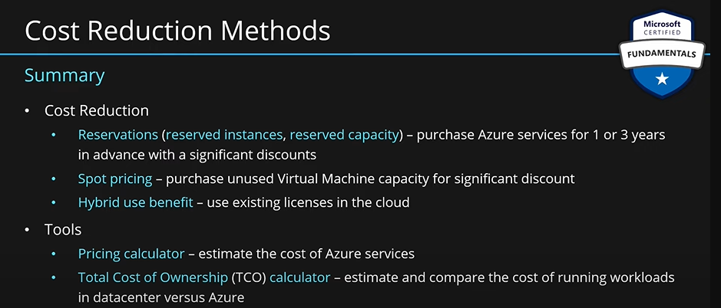

### Describe cost management capabilities in Azure.

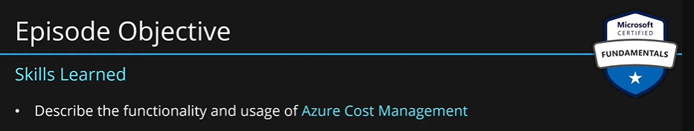

Microsoft Azure is a global cloud provider, meaning you can provision resources anywhere in the world. You can provision resources rapidly to meet a sudden demand, or to test out a new feature, or on accident. If you accidentally provision new resources, you may not be aware of them until it’s time for your invoice. Cost Management is a service that helps avoid those situations.

Cost of azure enviornment is based on the usage. If we need more services, we scale them up and start paying more, if we don’t need, then we scale down and pay less.

Each service is tracked separately. You only pay for what you use.

Each service has multiple matrix based on which you are charged.

**What is Cost Management?:**

Cost Management provides the ability to quickly check Azure resource costs, create alerts based on resource spend, and create budgets that can be used to automate management of resources.

Cost analysis is a subset of Cost Management that provides a quick visual for your Azure costs. Using cost analysis, you can quickly view the total cost in a variety of different ways, including by billing cycle, region, resource, and so on.

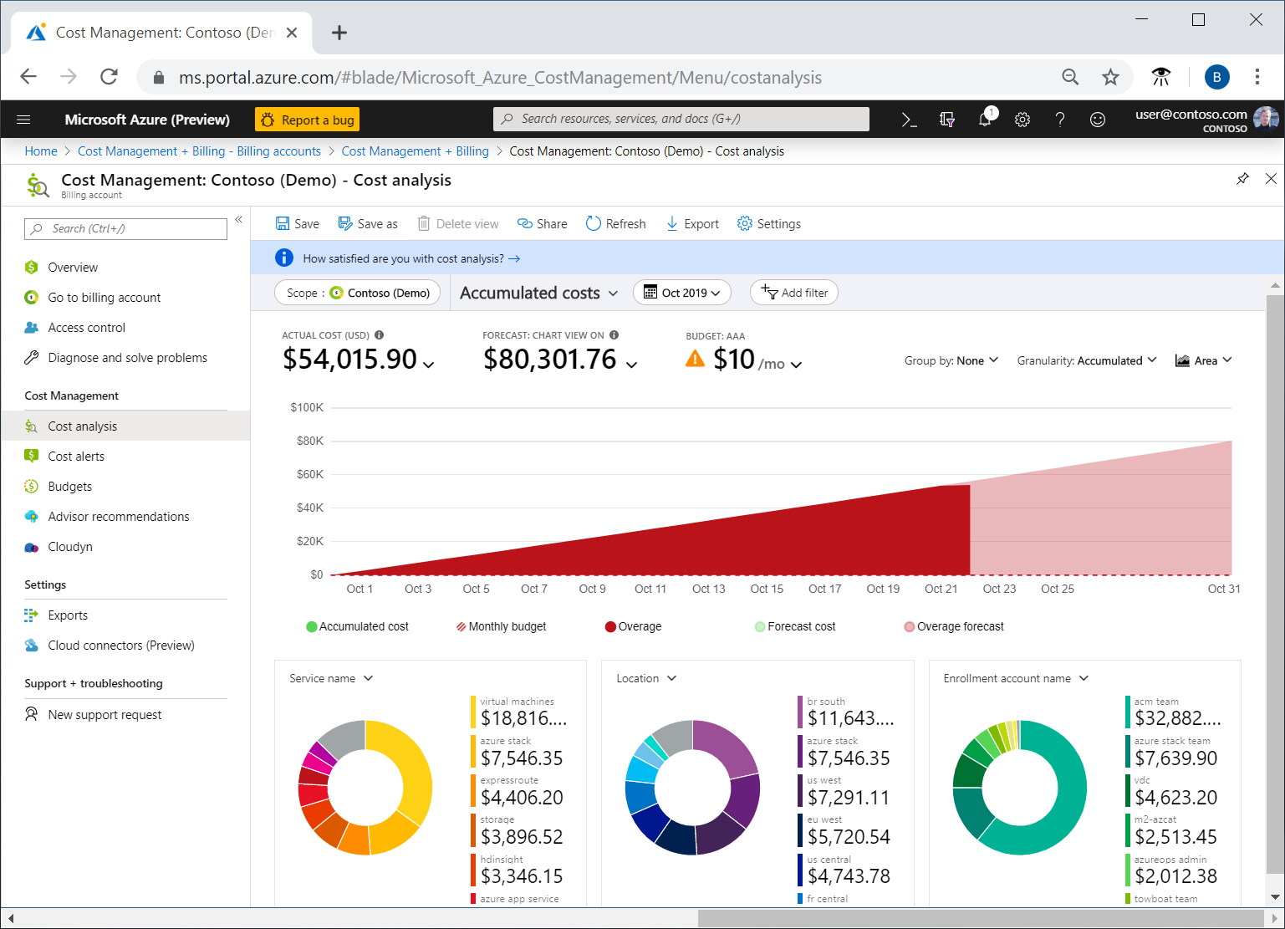

You use cost analysis to explore and analyze your organizational costs. You can view aggregated costs by organization to understand where costs are accrued and to identify spending trends. And you can see accumulated costs over time to estimate monthly, quarterly, or even yearly cost trends against a budget.

**Cost alerts**

Cost alerts provide a single location to quickly check on all of the different alert types that may show up in the Cost Management service. The three types of alerts that may show up are:

* **Budget alerts**
* **Credit alerts**
* **Department spending quota alerts.**

**Budget alerts**

Budget alerts notify you when spending, based on usage or cost, reaches or exceeds the amount defined in the alert condition of the budget. Cost Management budgets are created using the Azure portal or the Azure Consumption API.

In the Azure portal, budgets are defined by cost. Budgets are defined by cost or by consumption usage when using the Azure Consumption API. Budget alerts support both cost-based and usage-based budgets. Budget alerts are generated automatically whenever the budget alert conditions are met. You can view all cost alerts in the Azure portal. Whenever an alert is generated, it appears in cost alerts. An alert email is also sent to the people in the alert recipients list of the budget.

**Credit alerts**

Credit alerts notify you when your Azure credit monetary commitments are consumed. Monetary commitments are for organizations with Enterprise Agreements (EAs). Credit alerts are generated automatically at 90% and at 100% of your Azure credit balance. Whenever an alert is generated, it's reflected in cost alerts, and in the email sent to the account owners.

**Department spending quota alerts**

Department spending quota alerts notify you when department spending reaches a fixed threshold of the quota. Spending quotas are configured in the EA portal. Whenever a threshold is met, it generates an email to department owners, and appears in cost alerts. For example, 50 percent or 75 percent of the quota.

**Budgets**

A budget is where you set a spending limit for Azure. You can set budgets based on a subscription, resource group, service type, or other criteria. When you set a budget, you will also set a budget alert. When the budget hits the budget alert level, it will trigger a budget alert that shows up in the cost alerts area. If configured, budget alerts will also send an email notification that a budget alert threshold has been triggered.

A more advanced use of budgets enables budget conditions to trigger automation that suspends or otherwise modifies resources once the trigger condition has occurred.

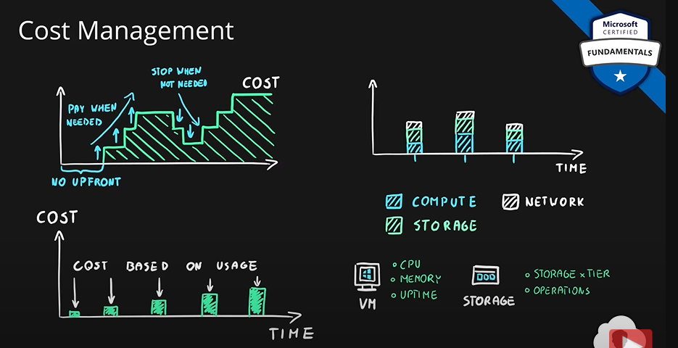

**Azure Cost Management** grabs all of this data and presents in a format which is easy to understand.

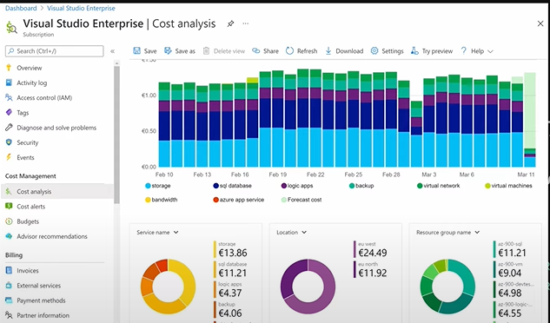

Self service reporting capability tool within azure.

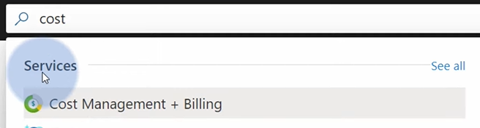

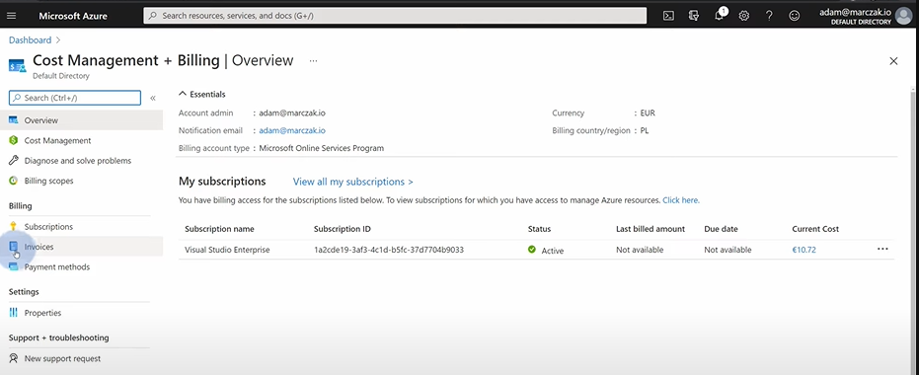

Click the subscription for which you want the details.

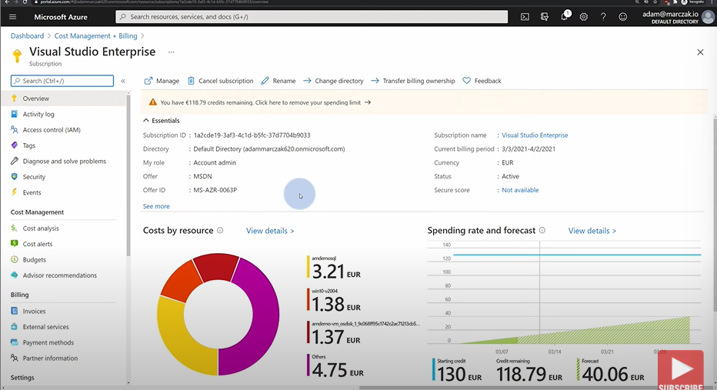

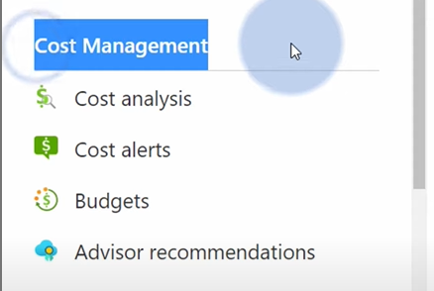

Select cost analysis on the left hand side to see details.

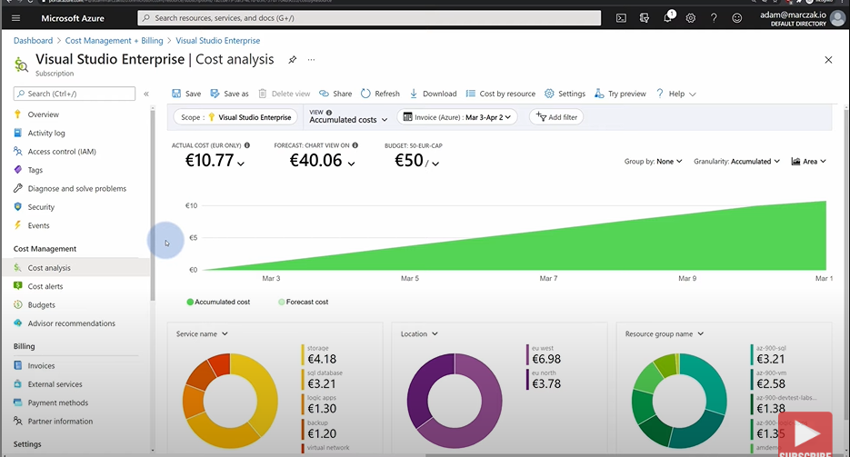

Select the period to find monthly billing data.



Use three menus on the left hand side to see specific billing data.

Details service wise:

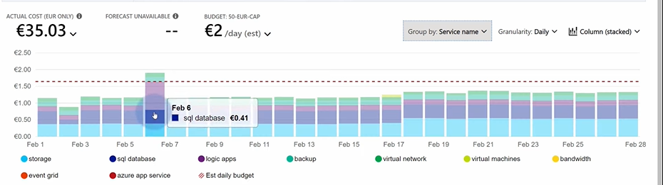

**Budgets:** They allow you to track the spendind on azure. You get notified when you are nearing the budget limit.

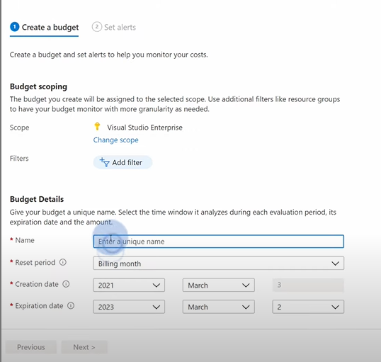 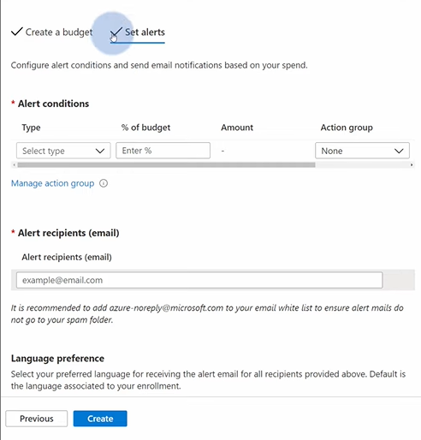

You can set alert based on how much budget has been used.

Remember that budgets are not hard limits. Your services may consume more than your budget. But you can do some autmation based on budget. For example, when the budget is reached, you can run a script which will shut down your VMs or something else.

You can find the cost management section at every level. Subscition level, resource group level and resource level.

A resource group owner can go to cost management 🡪 cost analysis and see the billing for their resource group.

Cost management is linked with azure advisor. So, you can see cost recommendations as well.

Cost management also allows you to have your bilings details converted to CSV and uploaded to azure blob.

**Summary:**

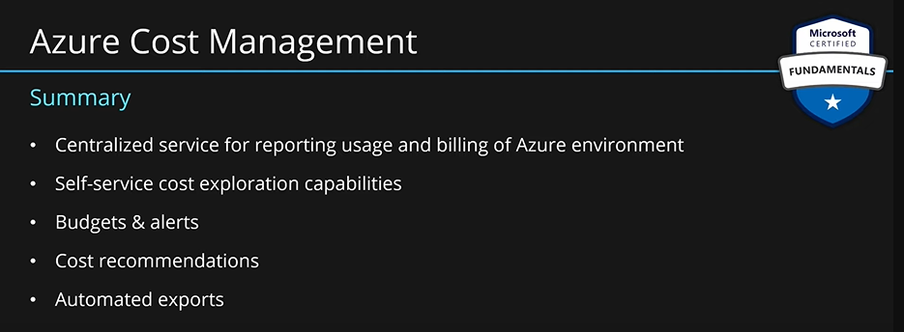

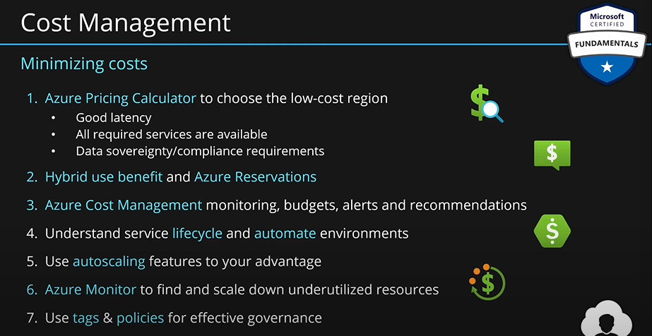

### Describe the purpose of tags.

**Resource Tags:**

As your cloud usage grows, it's increasingly important to stay organized. A good organization strategy helps you understand your cloud usage and can help you manage costs.

One way to organize related resources is to place them in their own subscriptions. You can also use resource groups to manage related resources. Resource tags are another way to organize resources. Tags provide extra information, or metadata, about your resources. This metadata is useful for:

* **Resource management Tags** enable you to locate and act on resources that are associated with specific workloads, environments, business units, and owners.
* **Cost management and optimization Tags** enable you to group resources so that you can report on costs, allocate internal cost centers, track budgets, and forecast estimated cost.
* **Operations management** Tags enable you to group resources according to how critical their availability is to your business. This grouping helps you formulate service-level agreements (SLAs). An SLA is an uptime or performance guarantee between you and your users.
* **Security Tags** enable you to classify data by its security level, such as public or confidential.
* **Governance and regulatory compliance Tags** enable you to identify resources that align with governance or regulatory compliance requirements, such as ISO 27001. Tags can also be part of your standards enforcement efforts. For example, you might require that all resources be tagged with an owner or department name.
* **Workload optimization and automation Tags** can help you visualize all of the resources that participate in complex deployments. For example, you might tag a resource with its associated workload or application name and use software such as Azure DevOps to perform automated tasks on those resources.

**How do I manage resource tags?**

You can add, modify, or delete resource tags through Windows PowerShell, the Azure CLI, Azure Resource Manager templates, the REST API, or the Azure portal.

You can use Azure Policy to enforce tagging rules and conventions. For example, you can require that certain tags be added to new resources as they're provisioned. You can also define rules that reapply tags that have been removed. Resources don't inherit tags from subscriptions and resource groups, meaning that you can apply tags at one level and not have those tags automatically show up at a different level, allowing you to create custom tagging schemas that change depending on the level (resource, resource group, subscription, and so on).

**An example tagging structure:**

A resource tag consists of a name and a value. You can assign one or more tags to each Azure resource.

Name Value

AppName The name of the application that the resource is part of.

CostCenter The internal cost center code.

Owner The name of the business owner who's responsible for the resource.

Environment An environment name, such as "Prod," "Dev," or "Test."

Impact How important the resource is to business operations, such as "Mission-critical," "High-impact," or "Low-impact."

Keep in mind that you don't need to enforce that a specific tag is present on all of your resources. For example, you might decide that only mission-critical resources have the Impact tag. All non-tagged resources would then not be considered as mission critical.

What we usually do in azure is that we create resource groups based on let’s say app name, then we will put all the resources related to that app inside that app’s resource group.

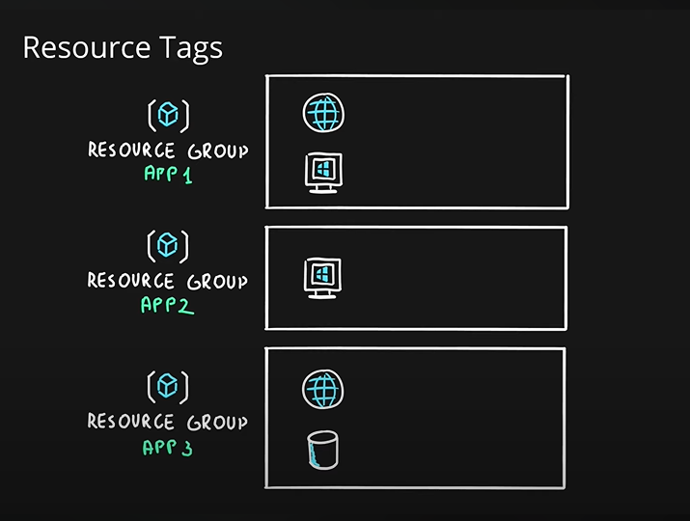

If later, you want to change the name of the resource group, there is no option to do that. You will be forced to create a new resource group and move all resources to this new group. To avoid this we can make use of resource tags.

Let’s say we want to add department name information to the resources, we can add a tag to that resource; **department name: finance.** Tags are **name: value** pairs. You can add multiple tags to a single resource. You can also add tags on resource groups as well.

Note: resource tags are not inherited by default. That means the resource tag attached to a resource group will not be attached to the child resources automatically. This can be done by **azure policy,** which we will learn later.

Tags allow you to add extra information to your resources/resource groups.

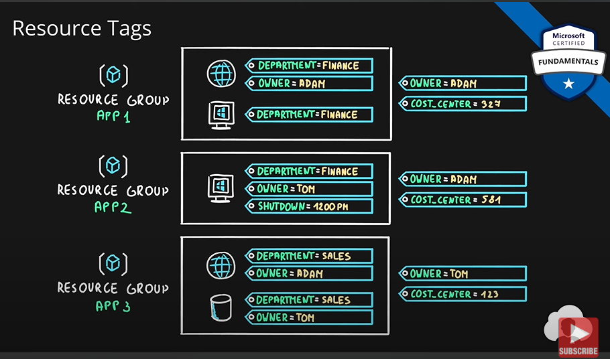

While creating a resource group, we see a page like this:

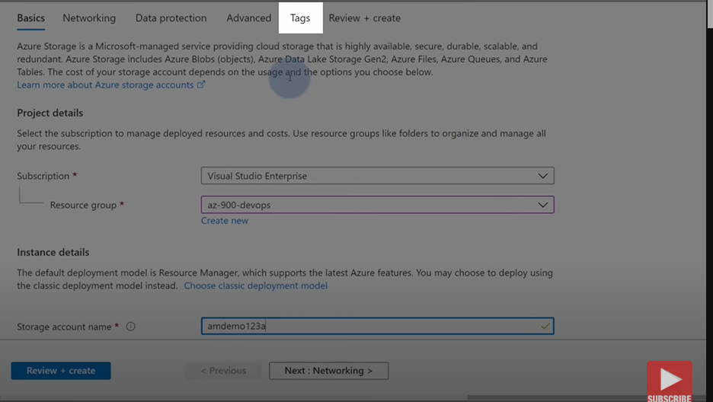

Remember, tags don’t do anything. They are just extra information with resource/resources groups. They can help in better management of resource/resources.

We can see cost of resources based on tags:

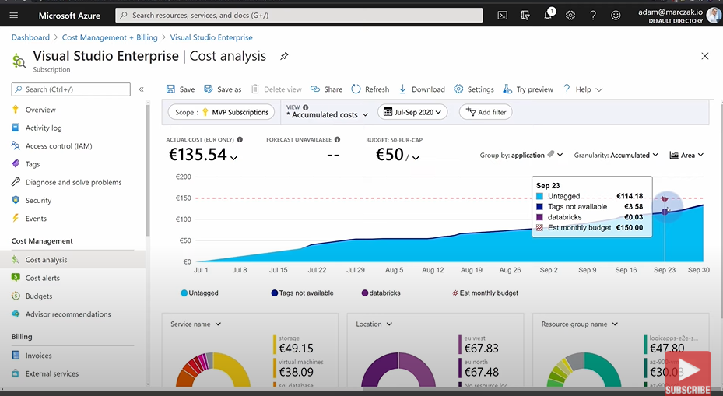

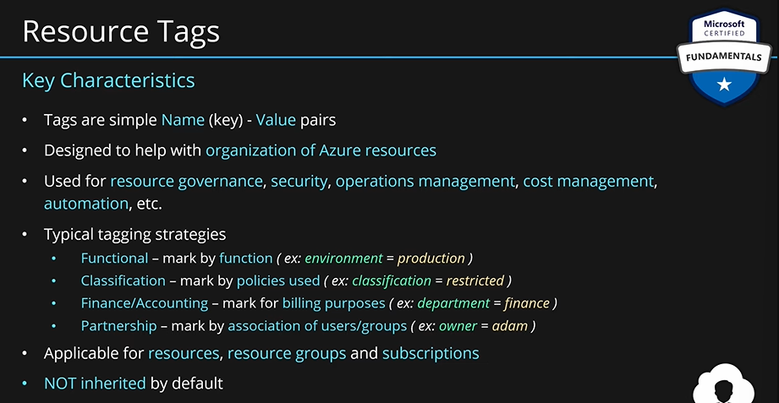

Also you cannot have two tags with the same name for a single azure resource.

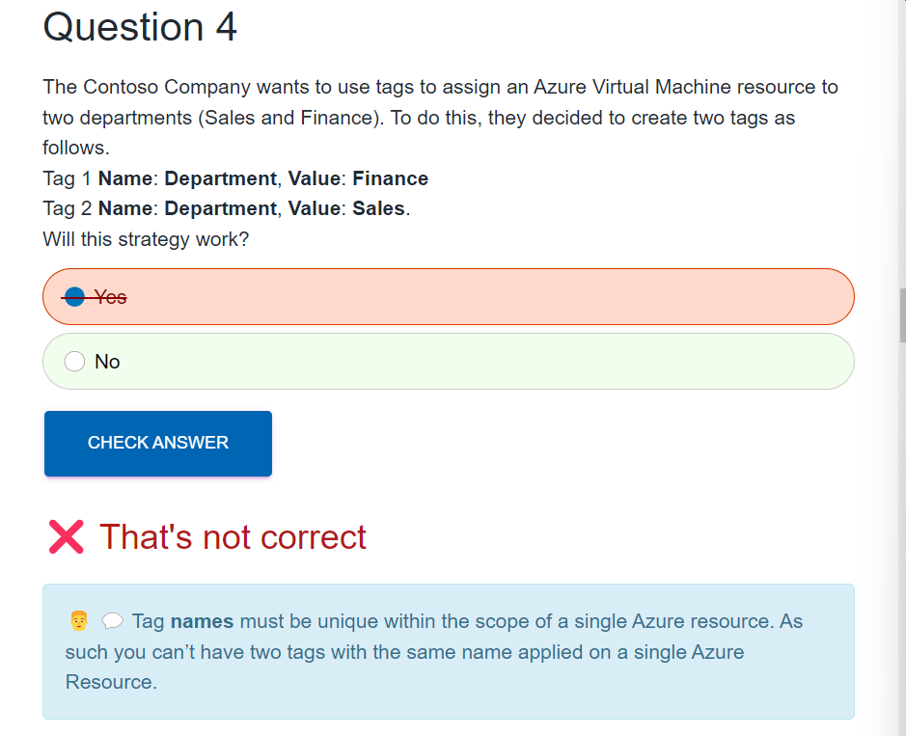

## Describe features and tools in Azure for governance and compliance.

### Describe the purpose of Microsoft Purview in Azure.

**Describe the purpose of Microsoft Purview:**

Microsoft Purview is a family of data governance, risk, and compliance solutions that helps you get a single, unified view into your data. Microsoft Purview brings insights about your on-premises, multicloud, and software-as-a-service data together.

With Microsoft Purview, you can stay up to date on your data landscape thanks to:

* Automated data discovery
* Sensitive data classification
* End-to-end data lineage

Two main solution areas comprise Microsoft Purview: **risk and compliance and unified data governance.**

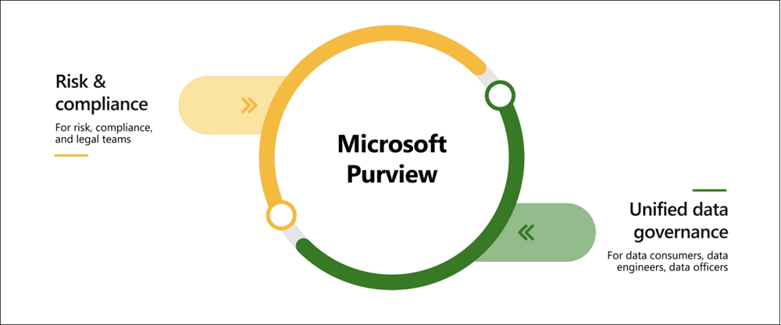

**Microsoft Purview risk and compliance solutions**

Microsoft 365 features as a core component of the Microsoft Purview risk and compliance solutions. Microsoft Teams, OneDrive, and Exchange are just some of the Microsoft 365 services that Microsoft Purview uses to help manage and monitor your data. Microsoft Purview, by managing and monitoring your data, is able to help your organization:

* Protect sensitive data across clouds, apps, and devices.
* Identify data risks and manage regulatory compliance requirements.
* Get started with regulatory compliance.

**Unified data governance**

Microsoft Purview has robust, unified data governance solutions that help manage your on-premises, multicloud, and software as a service data. Microsoft Purview’s robust data governance capabilities enable you to manage your data stored in Azure, SQL and Hive databases, locally, and even in other clouds like Amazon S3.

Microsoft Purview’s unified data governance helps your organization:

* Create an up-to-date map of your entire data estate that includes data classification and end-to-end lineage.
* Identify where sensitive data is stored in your estate.
* Create a secure environment for data consumers to find valuable data.
* Generate insights about how your data is stored and used.
* Manage access to the data in your estate securely and at scale.

When you have multiple IT and engineering teams, how can you control what access they have to the resources in your cloud environment? The principle of least privilege says you should only grant access up to the level needed to complete a task. If you only need read access to a storage blob, then you should only be granted read access to that storage blob. Write access to that blob shouldn’t be granted, nor should read access to other storage blobs. It’s a good security practice to follow.

However, managing that level of permissions for an entire team would become tedious. Instead of defining the detailed access requirements for each individual, and then updating access requirements when new resources are created or new people join the team, Azure enables you to control access through Azure role-based access control (Azure RBAC).

Azure provides built-in roles that describe common access rules for cloud resources. You can also define your own roles. Each role has an associated set of access permissions that relate to that role. When you assign individuals or groups to one or more roles, they receive all the associated access permissions.

So, if you hire a new engineer and add them to the Azure RBAC group for engineers, they automatically get the same access as the other engineers in the same Azure RBAC group. Similarly, if you add additional resources and point Azure RBAC at them, everyone in that Azure RBAC group will now have those permissions on the new resources as well as the existing resources.